### Growz - AI Crop Recommendation System

*Submitted for partial fulfillment of the requirements for the award of*

#### BACHELOR OF TECHNOLOGY

**in**

#### COMPUTER SCIENCE ENGINEERING –

#### ARTIFICIAL INTELLIGENCE & MACHINE LEARNING

By

#### V. Sree Lakshmi Tirumala - 20BQ1A4261

**M. Venkata Jyothi Priya** - **20BQ1A4237**

#### B. Bhargav - 20BQ1A4207

**T. Mahesh Chandra** - **20BQ1A4254**

Under the guidance of

**Mr. K. BALAKRISHNA** B.Tech.,MBA.,M.Tech.,DID.,(PhD)

**ASSISTANT PROFESSOR**



#### DEPARTMENT OF COMPUTER SCIENCE ENGINEERING -

**ARTIFICIAL INTELLIGENCE & MACHINE LEARNING**

(B. Tech Program is Accredited by NBA)

#### VASIREDDY VENKATADRI INSTITUTE OF TECHNOLOGY

Permanently Affiliated to JNTU Kakinada, Approved by AICTE Accredited by NAAC with ‘A’ Grade, ISO 9001:2008 Certified

NAMBUR (V), PEDAKAKANI (M), GUNTUR – 522 508

Tel no: 0863-2118036, url: www.vvitguntur.com

(April 2024)

#### DECLARATION

We, Ms. M. Venkata Jyothi Priya, Ms. V. Sree Lakshmi Tirumala, Mr. B. Bhargav,

Mr. T. Mahesh Chandra hereby declare that the Project Report entitled **“Growz-AI Crop Recommendation System”** done by us under the guidance of Mr. K. Balakrishna, Assistant Professor, Computer Science & Engineering - Artificial Intelligence & Machine Learning at Vasireddy Venkatadri Institute of Technology is submitted for partial fulfillment of the requirements for the award of Bachelor of Technology in Computer Science & Engineering - Artificial Intelligence & Machine Learning. The results embodied in this report have not been submitted to any other University for the award of any degree.

DATE :

PLACE :

SIGNATURE OF THE CANDIDATE (S)

**ACKNOWLEDGEMENT**

We take this opportunity to express my deepest gratitude and appreciation to all those people who made this project work easier with words of encouragement, motivation, discipline, and faith by offering different places to look to expand my ideas and helped me towards the successful completion of this project work.

First and foremost, we express my deep gratitude to **Mr. Vasireddy Vidya Sagar**, Chairman, Vasireddy Venkatadri Institute of Technology for providing necessary facilities throughout the B.Tech programme.

We express my sincere thanks to **Dr. Y. Mallikarjuna Reddy**, Principal, Vasireddy Venkatadri Institute of Technology for his constant support and cooperation throughout the B.Tech programme.

We express my sincere gratitude to **Dr. K. Suresh Babu**, Professor & HOD, Computer Science & Engineering - Artificial Intelligence & Machine Learning, Vasireddy Venkatadri Institute of Technology for his constant encouragement, motivation and faith by offering different places to look to expand my ideas.

We would like to express my sincere gratefulness to our Guide **Mr.** **K. Balakrishna**, Assistant Professor, Computer Science & Engineering - Artificial Intelligence & Machine Learning for his insightful advice, motivating suggestions, invaluable guidance, help and support in successful completion of this project.

We would like to express our sincere heartfelt thanks to our Project Coordinator **Mr. N. Balayesu**, Assistant Professor, Computer Science & Engineering - Artificial Intelligence & Machine Learning for his valuable advices, motivating suggestions, moral support, help and coordination among us in successful completion of this project.

We would like to take this opportunity to express my thanks to the **Teaching and Non-Teaching** Staff in the Department of Computer Science & Engineering - Artificial Intelligence & Machine Learning, VVIT for their invaluable help and support.

**Name (s) of Students**

Mulaka Venkata Jyothi Priya

Varikuti Sree Lakshmi Tirumala

Brahmadesam Bhargav

Talluri Mahesh Chandra

**VASIREDDY VENKATADRI INSTITUTE OF TECHNOLOGY**



Permanently Affiliated to JNTUK, Kakinada, Approved by AICTE Accredited by NAAC with ‘A’ Grade, ISO 9001:20008 Certified Nambur, Pedakakani (M), Guntur (Gt) -522508

**DEPARTMENT OF COMPUTER SCIENCE ENGINEERING- ARTIFICIAL INTELLIGENCE & MACHINE LEARNING**

**CERTIFICATE**

This is to certify that this **Project Report** is the Bonafide work of **Ms. M. Venkata Jyothi Priya, Ms. Sree Lakshmi Tirumala, Mr. B. Bhargav, Mr. T. Mahesh Chandra,** bearing Reg. No. **20BQ1A4237, 20BQ1A4261, 20BQ1A4207, 20BQ1A4254** respectively who had carried out the project entitled **“Growz-AI Crop Recommendation System”** under our supervision.

##### Project Guide Head of the Department

(Mr. K. Balakrishna, Assistant Professor) (Dr. K. Suresh Babu, Professor)

**Submitted for Viva voce Examination held on**

**Internal Examiner External Examiner**

##### TABLE OF CONTENTS

**CH No Title Page No**

Contents i

List of Figures iv

Nomenclature vi

Abstract vi

1. INTRODUCTION 2
   1. Background and rationale for the study 2
   2. Statement of the problem 3
   3. Aims and objectives of the research 4
   4. Research questions or hypotheses 5
      1. Research Questions 5
      2. Hypotheses 6
   5. Scope and limitations of the study 7
   6. Peculiarity of Project 8
2. LITERATURE SURVEY 10
   1. Evolution of Agricultural Management 11
   2. Advancements in Agricultural Technology 12
   3. Revolutionizing Agriculture 13
   4. Transforming Agriculture 13
   5. Tele-Agriculture 14
   6. Challenges in AI Implementation: Privacy, ethics, regulation 15
   7. The Future of Crop Recommendation Systems 16
   8. Conclusion 17
3. PROPOSED SYSTEM 19
   1. Existing System 19
      1. Disadvantages 20
   2. Proposed System 21
      1. Advantages 23
   3. Methodology 24
      1. Description of the AI model development process 24
      2. Data collection for various features 25
      3. Details of the algorithm and software used 26
      4. User role definitions and interactions 27
      5. Ethical considerations and data privacy measures 28
   4. System Requirements 28
      1. Software Requirements 28
      2. Hardware Requirements 29
   5. System Design 29
      1. Input Design 29
      2. Output Design 30
   6. UML Diagrams 30
      1. Use Case Diagram 31
      2. Class Diagram 32
      3. Sequence Diagram 33
      4. Collaboration Diagram 33
      5. Activity Diagram 34
      6. Component Diagram 34
      7. Deployment Diagram 35
      8. ER Diagram 36
      9. DFD Diagram 37
4. IMPLEMENTATION 40
   1. Deep Learning Algorithms 40
      1. CNN Model 40
   2. Machine Learning Algorithms 43
      1. K-Means Algorithm 43
   3. Visual Studio Code 54
   4. Python Flask Server 54
   5. Fire Base Authentication 54
5. RESULTS 57
6. CONCLUSION AND FUTURE SCOPE 60
7. REFERENCES 68

APPENDIX

Conference Presentation Certificate **71**

Journal Published Paper **72**

#### LIST OF FIGURES

|  |  |  |
| --- | --- | --- |
| **Figure No** | **Figure Name** | **Page No** |
| 1.1 | Use Case Diagram | 32 |
| 1.2 | Class Diagram | 33 |
| 1.3 | Sequence Diagram | 33 |
| 1.4 | Activity Diagram | 34 |
| 1.5 | Collaborative Diagram | 35 |
| 1.6 | Component Diagram | 35 |
| 1.7 | Deployment Diagram | 36 |
| 1.8 | ER Diagram | 37 |
| 1.9 | DFD Diagram | 38 |
| 2 | Architecture of CNN | 41 |
| 2.1 | Block Diagram of Plant Disease Detection | 41 |
| 2.2 | Flow Chart of K-Means Algorithm | 44 |
| 5.1 | Home Page Design | 58 |
| 5.2 | User Registration and Authentication | 59 |
| 5.3 | Crop Prediction | 60 |
| 5.4 | Plant Disease Detection | 60 |
| 5.5 | Fertilizer Recommendation | 61 |
| 5.6 | Market Demand Insights | 61 |
| 5.7 | yield Prediction | 62 |
| 5.8 | Location Based Crop Recommendation | 62 |
| 5.9 | Seasonal Notifications | 63 |

6 Language Selection 63

#### NOMENCLATURE

|  |  |
| --- | --- |
| ML | Machine Learning |
| DL | Deep Learning |
| AI | Artificial Intelligence |
| CNN | Convolution Neural Network |
| PC | Personal Computer |
| ER | Entity Relationship |
| DFD | Data Flow Diagram |

#### ABSTRACT

Agriculture is a crucial pillar of many economies, significantly contributes to Gross Domestic Product (GDP). The challenge faced by farmers in choosing the right crop is exacerbated by factors like climate changes, soil variations, and limited knowledge of modern farming methods. This issue extends to both domestic and farmland, as environmental conditions such as temperature, water levels, and soil quality remain unpredictable. To address this problem, our research proposes a system aiding farmers in crop selection by considering factors such as sowing season, soil type, and geographical location. Moreover, the integration of precision agriculture, leveraging modern technology, is gaining ground in developing nations, focusing on crop management tailored to specific sites. This paper introduces machine learning techniques, including k-Means and Decision Tree, to predict the optimal crop for a given soil type based on comprehensive datasets. The app utilizes market demand analysis to empower farmers with insights into current market trends and prices, enabling informed decision-making regarding crop selection and production volume. Continuous feedback mechanisms foster a collaborative community where farmers can share experiences and insights, contributing to ongoing improvements in crop recommendations and agricultural practices. By encompassing these diverse functionalities, our app aims to revolutionize farming practices, promote sustainable agriculture, and empower farmers to thrive in dynamic agricultural landscapes.

**Keywords:** Location-Based Crop Recommendation, Soil Analysis and Recommendation, Market Demand Insights Prediction, Fertilizers Recommendation, Yield Prediction, Plant Disease Prediction, Seasonal Notification

Agriculture plays a vital role in the socioeconomic fabric of India. Failure of farmers to decide on the best-suited crop for the land using traditional and non-scientific methods is a serious issue for a country where approximately 58 percent of the population is involved in farming.

Sometimes farmers were failed to choose the right crops based on the soil conditions, sowing season, and geographical location. This results in suicide, quitting the agriculture field, moving towards urban areas for livelihood. Crops are recommended based on soil, weather, humidity, rainfall, and other variables to increase agricultural output. It benefits not just farmers, but also the country and helps to keep food costs down.

Agriculture is the backbone of the economy in many countries, contributing significantly to their Gross Domestic Product (GDP). The right choice of crop plays a critical role in ensuring good yield and profitability for farmers. However, farmers often face the challenge of selecting the right crop due to a variety of factors such as changing climate patterns, varying soil conditions, and limited knowledge about modern agricultural practices. It has been a major problem to identify what to grow, any man has adequate space in the owner’s land. Not only domestic lands but also for farming lands. Why it has become a problem is that environmental factors such as temperature, water levels, and soil conditions are uncertain as they change from time to time To overcome this issue, this research work has proposed a system to assist the farmers in crop selection by considering all the factors like sowing season, soil, and geographical location. Furthermore, precision agriculture is being implemented with a modern agricultural technology and it is evolving in developing countries that concentrates on site-specific crop management. This paper presents the utilization of machine learning approaches like Random Forest and Decision Tree to predict which crop is best for which soil type based on the data sets.

##### Background and rationale for the study

The prevalence of agricultural challenges globally is a significant concern, with crop-related issues ranking among the top causes of reduced yield and economic losses for farmers. The complexity of agricultural systems, combined with factors such as climate variability and resource constraints, highlights the need for accessible decision support tools. This necessity has sparked interest in leveraging artificial intelligence (AI) to bridge the gap in crop management. The application of AI, particularly convolutional neural networks (CNNs) such as ResNet50, VGG19, and Xception, has demonstrated promising results in image recognition tasks, making them suitable candidates for crop recommendation systems. These models can be trained to analyze

visual data from fields, such as satellite imagery or drone footage, to identify crop health, pest infestations, nutrient deficiencies, and other factors affecting yield. Moreover, integrating AI into agriculture aligns with digital transformation trends, enabling precision farming practices and optimizing resource allocation. By providing timely recommendations through AI-driven platforms, farmers can make informed decisions about crop management strategies, leading to improved productivity and profitability. This study aims to develop and assess an AI-based crop recommendation system that can support farmers in making data-driven decisions. By offering multilingual support and catering to diverse agricultural contexts, the tool aims to democratize access to advanced farming technologies. The research will contribute to the ongoing discourse on AI in agriculture, emphasizing practical applications for optimizing crop production and ensuring food security.

##### Statement of the problem

In agricultural practices, the choice of crops to cultivate heavily impacts the productivity, sustainability, and profitability of farming operations. However, farmers often face challenges in selecting the most suitable crops for their specific environmental conditions, soil types, available resources, and market demand. To address these challenges and promote agricultural optimization, a Crop Recommendation System is proposed.

The Crop Recommendation System aims to leverage data analytics, machine learning algorithms, and agronomic knowledge to provide personalized recommendations to farmers regarding the optimal selection of crops for their individual farming scenarios. The system will take into account various factors including:

* + - Geographical Location: Different regions have varying climatic conditions, soil types, and water availability, which directly influence crop suitability. The system will utilize geospatial data to determine the specific location of the farm.
    - Soil Characteristics: Soil composition, pH levels, nutrient content, and drainage capacity profoundly impact crop growth. By analyzing soil samples or utilizing existing soil databases, the system will assess soil properties to recommend crops that thrive in the given soil conditions.
    - Climatic Conditions: Temperature, rainfall patterns, humidity levels, and seasonal variations significantly affect crop performance. The system will integrate historical weather data and climate forecasts to understand the prevailing climatic conditions and recommend crops that are resilient to these conditions.
    - Crop Rotation and Diversity: Continuous cultivation of the same crop can lead to soil degradation, pest outbreaks, and reduced yields. The system will consider crop rotation strategies and recommend diverse crop combinations to enhance soil fertility, minimize pest pressure, and optimize resource utilization.
    - Market Demand and Economic Viability: Crop selection should align with market demand to ensure profitability for farmers. The system will incorporate market analysis and price trends to recommend crops that have high demand and favorable economic prospects.
    - Farmers’ Preferences and Constraints: Farmers may have specific preferences, constraints, or constraints such as available machinery, labor resources, or financial limitations. The system will incorporate these factors to tailor recommendations that align with the farmers’ preferences and operational capabilities.

By integrating these factors and employing advanced analytical techniques, the Crop Recommendation System will provide farmers with actionable insights to make informed decisions regarding crop selection, thereby enhancing agricultural productivity, sustainability, and profitability. The goal of this project is to develop an intelligent and user- friendly Crop Recommendation System that empowers farmers to optimize their crop selection process, mitigate risks, and maximize yields in a rapidly changing agricultural landscape**.**

##### Aims and objectives of the research

Develop an AI-based crop recommendation system to enhance agricultural productivity and sustainability by providing tailored recommendations to farmers. This aim is underpinned by several specific objectives:

* + - Evaluate AI Architectures: Investigate the suitability and performance of various AI architectures, including convolutional neural networks (CNNs) such as ResNet50, VGG19, and Xception, in analyzing agricultural data. The study aims to assess the ability of these models to accurately classify crop health, detect pests and diseases, and recommend appropriate interventions.
    - Data Collection and Preprocessing: Gather diverse datasets comprising satellite imagery, drone footage, weather data, soil composition, and historical crop yields. Preprocess and augment the data to ensure quality and enhance model training effectiveness.
    - Interface Design and Usability: Design an intuitive and user-friendly interface for farmers to interact with the crop recommendation system. The interface should enable easy input of relevant data such as location, crop type, and current farming practices, and provide clear recommendations in a timely manner.
    - Multilingual Support and Accessibility: Implement multilingual support to accommodate farmers from diverse linguistic backgrounds. The system should be accessible in languages commonly spoken by the target user population, ensuring inclusivity and ease of use.
    - Performance Evaluation: Evaluate the performance of the crop recommendation system in terms of accuracy, precision, recall, and overall effectiveness in improving crop yield and quality. Compare the recommendations generated by the AI system with traditional farming practices and expert agronomist advice.
    - Impact Assessment: Assess the impact of the AI-based recommendations on key agricultural metrics such as yield per hectare, resource utilization efficiency, and economic profitability. Measure the extent to which the system contributes to sustainable farming practices and resilience to environmental challenges.
    - Farmers' Adoption and Feedback: Solicit feedback from farmers regarding their experience with the crop recommendation system. Analyze user satisfaction, perceived usefulness, and barriers to adoption to iteratively improve the system's functionality and relevance to end-users.

By accomplishing these objectives, the research aims to empower farmers with advanced technological tools for informed decision-making, thereby enhancing agricultural productivity, resilience, and livelihoods.

##### Research questions or hypotheses

The study is guided by the following research questions and hypotheses:

##### Research Questions

* + - 1. How effectively can an AI-based crop recommendation system, utilizing various architectures such as ResNet50, VGG19, and Xception, provide tailored recommendations for optimizing crop yield and quality compared to traditional farming practices?
* This question delves into the potential of AI to revolutionize agricultural decision-making and its comparative performance in improving crop productivity and sustainability.
  + - 1. What is the usability and adoption rate of the AI-based crop recommendation system among farmers across different regions and farming practices?
* This explores the user interface, ease of interaction, and farmers' willingness to adopt AI-driven technologies, crucial for successful integration into farming workflows.
  + - 1. How does the implementation of multilingual support in the crop recommendation system impact its accessibility and effectiveness in diverse agricultural communities?
* This addresses the importance of language inclusivity in ensuring that the benefits of AI-driven agricultural technologies are accessible to farmers from various linguistic backgrounds.
  + - 1. What are the economic and environmental impacts of adopting AI-based recommendations on farm management practices, resource utilization, and overall sustainability?
* This question examines the broader implications of AI in agriculture, including its potential to optimize resource allocation, minimize environmental impact, and enhance long-term agricultural resilience.
  + - 1. How does the integration of AI-based recommendations into farming practices affect key performance indicators such as crop yield, input efficiency, and economic profitability?
* This evaluates the tangible benefits of AI-driven decision support systems in improving farm productivity, reducing production costs, and enhancing farmers' livelihoods.
  + - 1. What are the barriers and challenges to the widespread adoption of AI-based crop recommendation systems, and how can they be addressed?
* This investigates potential obstacles, such as technological barriers, lack of awareness, and trust issues, and explores strategies to overcome them to facilitate the successful implementation of AI in agriculture.

##### Hypotheses

The AI-based crop recommendation system will outperform traditional methods in providing tailored recommendations for optimizing crop yield and quality, demonstrating superior accuracy and effectiveness in agricultural decision-making.

* Both farmers and agricultural experts will rate the usability and user experience of the AI tool positively, indicating high acceptability and ease of integration into existing farming practices and workflows.
* The implementation of multilingual support in the crop recommendation system will lead to increased accessibility of agricultural advisory services for non-English speaking farmers, facilitating better adoption and utilization of AI- driven technologies across diverse linguistic demographics.
* The adoption of the AI-based crop recommendation system will result in improved efficiency in farm management practices, characterized by reduced input costs, increased yield per hectare, and enhanced overall profitability.
* The integration of AI-driven recommendations into farming practices will lead to sustainable agricultural outcomes, including optimized resource utilization, reduced environmental impact, and enhanced resilience to climate variability and pest outbreaks.
* Barriers to the widespread adoption of AI-based crop recommendation systems, such as technological complexity and trust issues, can be mitigated through targeted education and outreach initiatives, fostering greater acceptance and utilization among farmers and agricultural stakeholders

##### Scope and limitations of the study

The scope of this study encompasses the design, development, and evaluation of an AI-based crop recommendation system aimed at assisting farmers in optimizing agricultural productivity and sustainability. It involves the application of various AI architectures, including ResNet50, VGG19, and Xception, for analyzing agricultural data such as satellite imagery, weather patterns, soil composition, and historical crop yields. The research also focuses on designing a user-friendly interface for farmers to interact with the system and integrating multilingual support to cater to diverse linguistic demographics.

The study aims to assess the accuracy of the AI tool in providing tailored recommendations for crop management, its usability among farmers, and its impact on agricultural efficiency and sustainability. It will explore the system's potential to improve resource allocation, reduce environmental impact, and enhance long-term resilience in agricultural practices. Participants will include farmers from different regions and farming practices, as well as agricultural experts,

to evaluate the system's functionality and gather feedback on its performance and user experience.

However, the study faces several limitations. Firstly, the effectiveness of the AI tool relies heavily on the quality and diversity of the dataset used for model training. A limited or biased dataset may not accurately represent the complexities of diverse agricultural environments, thus limiting the system's applicability across various crops and regions. Secondly, while the system is designed to be multilingual, it may initially support only a limited number of languages, which could hinder accessibility for farmers with different linguistic backgrounds.

Additionally, the research is constrained by the level of technological acceptance and digital literacy among its target users, which may impact the adoption rate of the AI tool. Furthermore, the evaluation of the system's impact on agricultural efficiency will be measured within a limited timeframe, which may not capture long-term effects and benefits. This study will serve as a foundational step for future research, which could address these limitations through extended trials, broader linguistic support, and longitudinal studies on technology adoption in agriculture.

##### Peculiarity of the Project

The uniqueness of this project lies in its innovative approach to leveraging artificial intelligence for crop recommendation, marking a significant advancement in agricultural decision-making. By harnessing state-of-the-art AI architectures such as ResNet50, VGG19, and Xception, the project pioneers the application of AI in agricultural data analysis, potentially transforming farming practices worldwide. The tool's standout feature is its multilingual support, including languages like English and Telugu, which sets it apart as one of the first in its field to address linguistic barriers in agricultural advisory services.

This project goes beyond theoretical exploration and represents a tangible step towards practical agricultural solutions, aiming to enhance productivity and sustainability in farming communities. By democratizing access to advanced crop management tools, the project seeks to empower farmers, particularly those in underserved regions, and streamline agricultural workflows for improved efficiency. The potential impact of this AI-based crop recommendation system on global agriculture could signify a significant milestone in promoting sustainable food production and rural development, leading to more resilient and prosperous farming communities.

Recent studies have highlighted the effectiveness of Conv2D in accurately detecting plant diseases, boasting an impressive accuracy rate of 98 percent. This deep learning technique analyses images of plant leaves, enabling timely disease identification and management in agricultural settings. Additionally, crop recommendation systems utilizing the k-means algorithm consider geographical location, soil characteristics, and optimal fertilizer usage to aid farmers in making informed decisions, achieving an accuracy rate of 97 percent. Market demand analysis provides insights into current market trends and prices, allowing farmers to align production with consumer demand for enhanced profitability. Mobile applications equipped with seasonal notification features leverage platforms like Firebase to recommend suitable crops based on weather conditions, empowering farmers to make informed decisions and improve crop yields. User feedback mechanisms stored in platforms like Firebase facilitate continuous improvement and customization of agricultural recommendation systems, ensuring their effectiveness and relevance in real-world farming contexts.

1. Deep learning for plant disease detection

Recent studies have demonstrated the effectiveness of Conv2D, a deep learning technique, in accurately detecting plant diseases with a remarkable accuracy of 98 percent. By analysing images of plant leaves, Conv2D models can reliably identify diseases, enabling timely intervention and disease management in agricultural settings.

1. Crop recommendation based on location, soil type, and fertilizers recommendation with k- means algorithm

Utilizing the k-means algorithm, researchers have developed crop recommendation systems that consider factors such as geographical location, soil characteristics, and optimal fertilizer usage. With an impressive accuracy rate of 97 percent, these systems aid farmers in making informed decisions about crop selection, enhancing agricultural productivity and sustainability.

1. Market Demand Analysis

Agricultural decision support systems incorporate market demand analysis to provide farmers with insights into current market trends and prices. By leveraging this information, farmers can strategically align their production with consumer demand, maximizing profitability and market competitiveness.

1. Seasonal Notifications

Mobile applications equipped with seasonal notification features utilize platforms like Firebase to recommend suitable crops based on prevailing weather conditions and seasonal patterns. By providing timely guidance on optimal planting times and crop varieties, these apps empower farmers to make informed decisions, ultimately improving crop yields and profitability.

1. Feedback Mechanism

User feedback plays a crucial role in the iterative improvement of agricultural technologies. Systems storing feedback in platforms like Firebase allow farmers to provide valuable insights on system performance and usability. This feedback loop facilitates continuous refinement and customization of agricultural recommendation systems, ensuring their effectiveness and relevance in real-world farming context.

#### Evolution of Agricultural Management: Traditional Practices to Modern Crop Recommendation Systems

The evolution of agricultural management from traditional farming practices to modern crop recommendation systems mirrors a transition from age-old, experience-based techniques to data-driven, technologically-empowered methodologies. Historically, agriculture relied on traditional wisdom and local knowledge passed down through generations, often resulting in practices that were highly variable and dependent on environmental conditions. With the advent of modern agricultural science, there has been a paradigm shift towards evidence-based approaches and precision agriculture. Traditional practices such as crop rotation and organic farming have been augmented by the use of advanced technologies such as precision irrigation, remote sensing, and soil analysis. These technologies enable farmers to make data-driven decisions, optimize resource allocation, and minimize environmental impact. Furthermore, the current era of agricultural management is characterized by the emergence of AI-driven crop recommendation systems.

These systems leverage machine learning algorithms to analyse vast amounts of agricultural data, including satellite imagery, weather patterns, soil composition, and historical yields. By providing tailored recommendations for crop selection, planting schedules, and pest management strategies, these systems empower farmers to optimize yield and quality while reducing input costs. The integration of AI into agricultural management represents the forefront of innovation in farming practices, bridging the gap between traditional wisdom and modern technology to enhance agricultural productivity, sustainability, and resilience in the face of evolving environmental challenges.

#### Advancements in Agricultural Technology: Precision Farming, Remote Sensing, AI Innovations

The integration of technology in agriculture has brought about transformative advancements, with precision farming, remote sensing, and AI innovations revolutionizing contemporary agricultural practices. Precision farming, characterized by its targeted and site-specific approach, has become instrumental in optimizing crop production and resource utilization. By leveraging data-driven techniques such as variable rate application and GPS-guided machinery, farmers can tailor inputs such as water, fertilizers, and pesticides to specific areas of their fields, resulting in enhanced efficiency and productivity.

Remote sensing technologies play a pivotal role in modern agriculture by providing valuable insights into crop health, soil conditions, and environmental factors. Through satellite imagery, drones, and other aerial platforms, farmers can monitor their fields in real-time, detect anomalies, and make informed decisions regarding irrigation, pest management, and crop health interventions. Remote sensing enables proactive management practices, allowing farmers to mitigate risks and maximize yields.

AI innovations in agriculture are reshaping the way farmers approach decision-making and farm management. AI-powered crop recommendation systems analyze vast amounts of data, including historical yield data, weather patterns, soil composition, and pest prevalence, to generate personalized recommendations for farmers. These recommendations encompass optimal planting times, crop varieties, and cultivation practices, empowering farmers to optimize yields while minimizing inputs and environmental impact.

Furthermore, AI algorithms are increasingly being utilized for predictive analytics, disease detection, and yield forecasting, enabling farmers to anticipate challenges and implement preemptive strategies. The integration of AI-driven technologies into agriculture holds promise for enhancing sustainability, resilience, and profitability in farming operations.

Together, these advancements reflect a modern agricultural landscape where technology plays a central role in driving efficiency, sustainability, and innovation. By embracing precision farming, remote sensing, and AI innovations, farmers can navigate the complexities of modern agriculture more effectively, ensuring food security, environmental stewardship, and economic prosperity for future generations.

#### Revolutionizing Agriculture: Harnessing AI for Personalized and Data- Driven Crop Recommendation Systems

In the modern era of agriculture, maximizing crop yield while minimizing resource consumption is paramount. "Revolutionizing Agriculture: Harnessing AI for Personalized and Data-Driven Crop Recommendation Systems" represents a cutting-edge approach to address this challenge. By integrating artificial intelligence (AI) technology with comprehensive datasets, this innovative system offers personalized recommendations tailored to specific agricultural

contexts. Gone are the days of relying solely on traditional farming methods and intuition. With AI at the helm, farmers can leverage vast amounts of data ranging from soil composition and weather patterns to historical yield data and market trends. This wealth of information empowers the system to analyse and predict optimal crop choices for individual farms, taking into account factors such as soil health, climate conditions, and market demand. The personalized nature of these recommendations ensures that farmers can make informed decisions that align with their unique circumstances, ultimately leading to increased productivity and profitability. Moreover, by optimizing crop selection based on environmental factors and market dynamics, this data- driven approach promotes sustainability and resource efficiency in agriculture. With "Revolutionizing Agriculture," the future of farming is transformed, ushering in an era where AI serves as a vital ally in the quest for food security and agricultural sustainability. By harnessing the power of data and AI technology, farmers can navigate the complexities of modern agriculture with confidence, unlocking new levels of efficiency, resilience, and prosperity for the global farming community.

#### Transforming Agriculture: Leveraging Nanotechnology for Precision Crop Recommendation Systems

In the realm of agriculture, nanotechnology is emerging as a game-changer, promising to transform how we approach crop recommendation systems with unprecedented precision and efficacy. This revolutionary technology, which manipulates materials at the nanoscale, is poised to revolutionize traditional farming practices by offering tailored solutions for optimizing crop health and yield. Just as nanotechnology has revolutionized skincare and diagnostics by enhancing the delivery of active ingredients and enabling sensitive molecular detection, it holds immense promise for agriculture. By leveraging nanomaterials and nano sensors, farmers can gain unparalleled insights into soil health, nutrient availability, and plant performance at a molecular level. In precision agriculture, nanotechnology enables the development of smart, responsive systems that adapt to the specific needs of crops in real-time. Nanoparticles can deliver nutrients and agrochemicals directly to plant cells, ensuring maximum absorption and minimal waste. Additionally, nanoscale biosensors can monitor plant health indicators, such as moisture levels and nutrient deficiencies, allowing for early intervention and optimized resource management. Furthermore, nanotechnology facilitates the creation of nano based delivery systems for seeds, fertilizers, and pesticides, ensuring targeted and controlled release for optimal efficacy and minimal environmental impact. By precisely tailoring inputs to the needs of

individual crops and microenvironments, nanotechnology empowers farmers to achieve higher yields, improve crop quality, and enhance sustainability.

The integration of nanotechnology into crop recommendation systems represents a paradigm shift in agriculture, offering a more personalized, efficient, and sustainable approach to farming. By harnessing the power of nanotechnology, farmers can unlock new avenues for maximizing productivity while minimizing resource usage, paving the way for a more resilient and environmentally conscious agricultural future.

#### Tele-Agriculture: Revolutionizing Crop Recommendations with Remote Access & Enhanced Reach

Tele-Agriculture" is revolutionizing crop recommendation systems. This digital shift enables farmers to access tailored advice and expertise from agricultural specialists regardless of their location, breaking down geographical barriers and ensuring more equitable access to agricultural knowledge. Through tele-agriculture, farmers can easily share information about their crops, soil conditions, and environmental factors with agricultural experts via secure platforms. This streamlined process expedites the decision-making process, allowing for timely and informed crop recommendations. This approach is particularly beneficial for addressing challenges in remote or underserved agricultural regions. Moreover, tele-agriculture enables efficient triaging of farming issues, allowing agricultural specialists to prioritize urgent cases while providing guidance and recommendations for less severe concerns remotely. This optimization of resources and timely intervention contributes to improved crop health and yield. Additionally, tele-agriculture fosters collaboration among agricultural professionals, facilitating knowledge exchange, peer consultation, and ongoing education. Agricultural specialists can seek second opinions, discuss complex cases, and access training opportunities, enhancing their expertise and decision-making capabilities. In summary, "Tele-Agriculture" represents a significant advancement in crop recommendation systems, offering farmers a more accessible, efficient, and tailored approach to agricultural advice and expertise, suitable for the digital age

#### Challenges in AI Implementation for Crop Recommendation Systems: Privacy, Ethics, and Regulation

Implementing artificial intelligence (AI) in crop recommendation systems brings forth a host of challenges, particularly concerning privacy, ethics, and regulation. While AI holds immense potential to revolutionize agriculture by providing data-driven insights and personalized recommendations, safeguarding privacy, ensuring ethical use, and navigating regulatory frameworks are critical considerations. Privacy concerns arise from the collection and analysis of sensitive agricultural data, including farmer information, crop yields, and land characteristics. Protecting the confidentiality and integrity of this data is essential to maintain trust among farmers and stakeholders. Moreover, ensuring transparency in data collection, storage, and usage practices is paramount to address privacy apprehensions. Ethical considerations encompass the responsible development and deployment of AI algorithms in crop recommendation systems. Ethical dilemmas may arise concerning bias in data collection, algorithmic decision-making, and unintended consequences on farming practices and communities. It is imperative to prioritize fairness, accountability, and transparency in AI systems to mitigate ethical risks. Regulatory challenges stem from the evolving landscape of AI governance and agricultural policies. Existing regulations may not adequately address the unique complexities of AI in agriculture, leading to uncertainty and inconsistency in implementation. Harmonizing regulatory frameworks across jurisdictions and engaging stakeholders in policy development are essential to foster innovation while ensuring compliance with legal and ethical standards. Addressing these challenges requires a multifaceted approach involving collaboration among policymakers, agricultural stakeholders, AI developers, and researchers. Robust data protection measures, ethical guidelines, and regulatory frameworks must be established to promote responsible AI implementation in crop recommendation systems. Furthermore, continuous monitoring, evaluation, and adaptation of AI systems are necessary to address emerging privacy, ethical, and regulatory concerns effectively. In summary, navigating the challenges of privacy, ethics, and regulation is crucial for the successful implementation of AI in crop recommendation systems. By prioritizing privacy protection, ethical principles, and regulatory compliance, stakeholders can harness the full potential of AI to advance sustainable and equitable agriculture while respecting the rights and interests of farmers and communities.

#### The Future of Crop Recommendation Systems: Emerging Trends, Breakthroughs, and Evolution

* + - As technology continues to advance, the future of crop recommendation systems is poised for transformative growth, driven by emerging trends, breakthroughs, and evolutionary shifts. Several key factors are shaping the trajectory of these systems, paving the way for more efficient, sustainable, and data-driven approaches to agricultural decision-making.
    - One significant trend is the integration of artificial intelligence (AI) and machine learning (ML) algorithms into crop recommendation systems. These advanced technologies enable the analysis of vast amounts of agricultural data, including soil

health, weather patterns, crop performance, and market trends. By leveraging AI and ML, recommendation systems can provide more accurate, personalized, and timely advice to farmers, optimizing crop selection, planting schedules, and resource management strategies.

* + - Another notable trend is the proliferation of remote sensing technologies, such as satellite imagery, drones, and IoT sensors. These tools offer unprecedented insights into crop health, soil moisture levels, pest infestations, and other environmental factors, allowing for real-time monitoring and analysis. By integrating remote sensing data with crop recommendation systems, farmers can make informed decisions and take proactive measures to mitigate risks and maximize yields.
    - Furthermore, the future of crop recommendation systems will likely see increased emphasis on sustainability and resilience. With growing concerns about climate change, resource depletion, and food security, there is a growing need for agricultural practices that minimize environmental impact and promote ecosystem health. Recommendation systems will play a crucial role in guiding farmers towards more sustainable farming practices, such as conservation agriculture, organic farming, and precision irrigation.
    - In terms of breakthroughs, advancements in nanotechnology and biotechnology hold promise for revolutionizing crop recommendation systems. Nanomaterials, nanosensors, and biotechnological tools can enable targeted delivery of nutrients, pesticides, and other agrochemicals, enhancing crop productivity while minimizing environmental harm. Additionally, genetic engineering and gene editing technologies offer the potential to develop crops with improved resilience, disease resistance, and nutritional value, further enhancing the effectiveness of recommendation systems.
    - In summary, the future of crop recommendation systems is characterized by the integration of AI and ML, remote sensing technologies, sustainability-driven practices, and breakthroughs in nanotechnology and biotechnology. By embracing these trends and innovations, recommendation systems can empower farmers to make informed decisions, optimize resource usage, and adapt to evolving environmental challenges, ultimately contributing to a more resilient, sustainable, and productive agricultural future.

##### Conclusion

In conclusion, this literature survey has shed light on the transformative potential of advanced technologies in the realm of crop recommendation systems, mirroring the advancements seen in dermatology. Just as AI, telemedicine, and nanotechnology have revolutionized dermatological

diagnostics and treatment, they hold immense promise for optimizing agricultural practices and enhancing crop productivity. Artificial Intelligence stands at the forefront of innovation in crop recommendation systems, offering powerful data analysis capabilities to predict optimal crop choices, optimize resource allocation, and mitigate risks. By harnessing AI algorithms, farmers can make data-driven decisions tailored to their specific agricultural contexts, leading to improved yields and profitability. Similarly, tele-agriculture emerges as a vital tool for increasing accessibility and efficiency in agricultural advisory services, especially in remote or underserved areas. Through remote consultations and digital platforms, farmers can access expert advice, share information about their crops, and receive personalized recommendations, breaking down geographical barriers and empowering farmers to make informed decisions. More over, nanotechnology holds promise for revolutionizing crop management practices, enabling targeted delivery of nutrients, pesticides, and other agrochemicals to optimize plant health and productivity. Nanoscale sensors and materials offer real-time monitoring of soil conditions, pest infestations, and crop performance, facilitating proactive interventions and sustainable farming practices. Despite these promising advancements, challenges such as ethical considerations, privacy concerns, and regulatory complexities remain pertinent in the implementation of technology in agriculture. Addressing these challenges will be crucial for the responsible integration of advanced technologies into crop recommendation systems, ensuring equitable access, ethical use, and regulatory compliance. Looking ahead, the future of crop recommendation systems appears bright, characterized by ongoing innovation and a shift towards more data-driven, personalized, and sustainable farming practices. As technology continues to evolve, it will undoubtedly play a central role in shaping the future of agriculture, optimizing resource usage, and ensuring food security for generations to come.

##### Existing System

Currently, the agriculture sector faces significant challenges due to a lack of precise information about changing climate variations and the suitability of crops to specific climatic conditions. This challenge is exacerbated by the fact that each crop has its own unique requirements regarding temperature, rainfall, humidity, and other climatic features. To address these challenges, precision farming techniques have emerged as a promising solution that not only maintains crop productivity but also increases overall yield rates.

However, existing systems for recommending crop yields often fall short in terms of accessibility and cost-effectiveness. Many of these systems rely on hardware-based solutions, such as specialized sensors and equipment, which can be expensive to install and maintain. Additionally, these hardware-based systems may not be easily accessible to all farmers, particularly those in remote or resource-constrained regions.

While several solutions have been proposed to address these challenges, there remains a need for a user-friendly application that provides accurate and actionable crop recommendations. Such an application would empower farmers to make informed decisions about crop selection and management, ultimately improving agricultural productivity and sustainability.

##### Disadvantages

* + - 1. Dependency on Historical Data: Existing crop recommendation systems often rely heavily on historical data for training machine learning algorithms. This dependency may result in recommendations that are based on outdated information and do not account for recent changes in climate patterns or agronomic practices.
      2. Limited Accuracy in Dynamic Environments: Agricultural conditions are constantly changing due to factors such as climate variability, soil degradation, and pest outbreaks. Existing systems may struggle to accurately predict crop yields in dynamic environments, leading to suboptimal recommendations for farmers.
      3. Complexity of Data Integration: Integrating data from multiple sources, such as weather data, soil maps, satellite imagery, and market trends, can be challenging and prone to

errors. Existing systems may encounter difficulties in harmonizing disparate datasets, resulting in inconsistencies or inaccuracies in crop recommendations.

* + - 1. Bias and Generalization Issues: Machine learning algorithms used in existing crop recommendation systems may exhibit bias or generalize poorly across different regions or cropping systems. Biases in the training data or algorithmic assumptions may lead to skewed recommendations that do not account for local variations or farmer preferences.
      2. Lack of Transparency: Many existing crop recommendation systems operate as black- box models, making it difficult for farmers to understand the underlying logic or decision-making process. This lack of transparency may erode trust in the recommendations and hinder adoption by farmers who prefer more interpretable and explainable systems.
      3. Limited Customization and Adaptability: Existing crop recommendation systems may offer limited customization options for farmers to tailor recommendations to their specific needs or preferences. Farmers with unique cropping systems, local knowledge, or cultural practices may find it challenging to adapt generic recommendations to their individual contexts.
      4. Cost of Implementation and Maintenance: Implementing and maintaining existing crop recommendation systems, particularly those that rely on proprietary software or specialized expertise, can be costly for farmers or agricultural organizations. High costs may serve as a barrier to adoption, particularly for smallholder farmers or resource- constrained regions.
      5. Lack of User Engagement and Feedback: Some existing crop recommendation systems may lack mechanisms for user engagement and feedback, limiting opportunities for farmers to provide input, validate recommendations, or suggest improvements. This lack of two-way communication may result in less relevant or actionable recommendations for farmers.
      6. Vulnerability to Data Security Risks: Collecting and storing large volumes of agricultural data, including sensitive information such as farm locations and crop yields, may expose existing systems to data security risks such as unauthorized access, data breaches, or malicious attacks. Ensuring robust data protection measures and privacy safeguards is essential to mitigate these risks and build trust among users.
      7. Resistance to Change: Farmers may be resistant to adopting new technologies or changing established farming practices, particularly if they perceive existing crop recommendation systems as complex, unreliable, or incompatible with their traditional knowledge or beliefs. Overcoming resistance to change and promoting adoption requires effective communication, capacity building, and demonstration of tangible benefits.

##### Proposed System

In this project, we have proposed a comprehensive model aimed at addressing the existing challenges faced by farmers in crop selection and yield optimization. The novelty of the proposed system lies in its ability to guide farmers towards maximizing crop yield while also considering the profitability of specific crops for a given region.

Central to the proposed model is its capability to provide crop selection recommendations based on a synthesis of economic and environmental conditions. By analyzing factors such as rainfall patterns, temperature variations, soil types, and market demand, the system offers tailored suggestions to farmers regarding the most suitable crops for cultivation. This holistic approach ensures that farmers can make informed decisions that not only maximize yield but also align with market trends and economic viability.

Moreover, the proposed system integrates soil analysis as a critical component of its decision- making process. Through soil analysis, the system assesses the fertility, composition, and health of the soil, providing farmers with valuable insights into soil nutrient levels, pH balance, and organic matter content. This information enables farmers to implement targeted soil management practices, such as fertilizer application and soil amendments, to optimize soil health and enhance crop productivity.

Additionally, the system incorporates features such as seasonal alerts and market demand insights to further support farmers in their decision-making process. By providing timely information about upcoming planting seasons, weather forecasts, and consumer preferences, the system helps farmers anticipate and respond to changing agricultural conditions effectively. This proactive approach empowers farmers to adapt their cultivation strategies and maximize their profitability in dynamic market environments.

Furthermore, the system offers fertilizer recommendations based on soil analysis and crop nutrient requirements. By recommending the optimal type, quantity, and timing of fertilizer application, the system assists farmers in optimizing nutrient management practices and

minimizing input costs. This targeted approach not only improves crop yields but also promotes sustainable agriculture by reducing fertilizer runoff and environmental impact.

In conclusion, the proposed system encompasses all the features mentioned previously, including crop selection based on economic and environmental conditions, soil analysis, seasonal alerts, market demand insights, and fertilizer recommendations. By integrating these features into a unified platform, the system provides farmers with comprehensive decision support tools to maximize crop yield, profitability, and sustainability.

##### Advantages

* **Maximized Crop Yield:** Through a comprehensive analysis of economic, environmental, and agronomic factors, the proposed system guides farmers towards selecting crops optimized for their specific conditions. This ensures that farmers can make informed decisions leading to maximized crop yield, ultimately enhancing agricultural productivity and profitability.
* **Profitable Crop Selection:** Incorporating market demand insights allows farmers to align their crop selection with consumer preferences and market trends. By recommending crops in high demand and with favourable economic prospects, the system helps farmers optimize revenue potential and seize market opportunities, resulting in increased profitability and market competitiveness.
* **Improved Soil Health:** Leveraging soil analysis capabilities and tailored fertilizer recommendations, the system promotes sustainable soil management practices to optimize soil health and fertility. By providing insights into soil nutrient levels, pH balance, and organic matter content, farmers can implement targeted soil management strategies, leading to improved crop productivity and long-term soil sustainability.
* **Timely Decision Support:** The inclusion of seasonal alerts ensures farmers receive timely information about upcoming planting seasons, weather forecasts, and market trends. This proactive approach empowers farmers to plan and execute cultivation strategies effectively, minimizing risks associated with adverse weather conditions and market fluctuations, and capitalizing on favourable conditions.
* **Optimized Fertilizer Usage:** Offering fertilizer recommendations based on soil analysis and crop nutrient requirements enables farmers to optimize nutrient management practices. This ensures fertilizers are applied in the right type, quantity, and timing, minimizing input costs and environmental impact while maximizing nutrient uptake by crops, leading to improved yields and resource efficiency.
* **Enhanced Sustainability:** By promoting precision farming techniques and sustainable agriculture practices, the proposed system contributes to environmental sustainability. Optimizing resource utilization, minimizing input costs, and reducing environmental impact helps farmers operate more efficiently and responsibly, ensuring the long-term viability of agricultural production systems while meeting increasing demand for food supplies.
* **Market Demand Insights:** Incorporating market demand insights empowers farmers to align crop selection with consumer preferences, ensuring that cultivated crops meet market demand. By responding to market trends and consumer preferences, farmers can tailor their production to capitalize on market opportunities, enhancing market competitiveness and profitability.
* **User-Friendly Interface:** With an intuitive user interface and accessible design, the system enables farmers to input information about their farming operations, view recommendations, and take actionable steps easily. This user-friendly approach enhances usability and adoption, empowering farmers of all technical levels to leverage the system's benefits effectively.
* **Customization and Adaptability:** The system offers flexibility and customization options to accommodate diverse needs and preferences. Farmers can adjust parameters such as crop preferences, soil characteristics, and market considerations to tailor recommendations, ensuring relevance and effectiveness across various agricultural contexts.
* **Continuous Improvement:** Through iterative learning and feedback mechanisms, the system evolves and improves its performance over time. By incorporating user feedback, updating data models, and integrating new insights, the system remains relevant and effective, enabling farmers to adapt to changing agricultural conditions and technological advancements.

##### Methodology

##### Description of the AI model development process

Crop recommendation systems typically involve analyzing various factors such as soil type, climate, topography, and historical crop data to provide farmers with suggestions on the most suitable crops to cultivate in a particular area

* Data Collection: Gather data on soil types, climate conditions, topography, historical crop yields, and other relevant agricultural factors. This data can come from various sources such as government agencies, agricultural research institutions, and satellite imagery.
* Data Preprocessing: Clean and preprocess the collected data. This may involve removing outliers, filling missing values, and standardizing data formats.
* Feature Selection/Extraction: Identify the most relevant features that influence crop growth and yield. This may involve techniques such as principal component analysis (PCA) or domain knowledge from agronomists.
* Model Selection: Choose an appropriate machine learning or statistical model for crop recommendation. Common models include decision trees, support vector machines (SVM), and neural networks.
* Training the Model: Train the selected model using historical data on crop yields and environmental factors. The model should learn the relationships between input features (e.g., soil type, climate) and output labels (e.g., crop yields).
* Validation and Optimization: Validate the model's performance using cross-validation techniques and optimize hyperparameters to improve predictive accuracy.
* Testing: Evaluate the trained model on a separate test dataset to assess its generalization performance. This step ensures that the model can make accurate crop recommendations on unseen data.
* Deployment: Deploy the trained model as a crop recommendation system accessible to farmers through a user-friendly interface. The interface should allow users to input their location and receive personalized crop recommendations based on local conditions.
* Feedback Loop: Incorporate a feedback mechanism where farmers can provide information on their actual crop yields and the success of recommended crops. This feedback can be used to continuously improve the recommendation system over time.

##### Data collection for Various Features

The data collection phase for Crop Recommendation datasets is a critical step in the development of the AI model. This process involves gathering a large and diverse set of crop recommendation images to train the AI system, ensuring it can accurately recognize and diagnose a wide range of Agricultural conditions.

* Source Selection: Obtain data from various sources including agricultural research institutions, government agencies, agricultural extension services, and online databases. Collaborate with agronomists, farmers, and agricultural experts to access verified and high-quality data.
* Inclusivity and Diversity: Ensure the dataset covers a wide range of crops, geographical locations, and environmental conditions. Include data from different regions, climates, and soil types to ensure the model's applicability across diverse agricultural settings.
* Ethical Considerations and Consent: Adhere to ethical guidelines and obtain consent when necessary, especially when collecting data from individual farmers or agricultural organizations. Respect privacy and confidentiality concerns.
* Quality Control: Vet the data for accuracy, relevance, and completeness. Ensure that the dataset contains clear, well-documented information about plant diseases, crop yields, fertilizer applications, soil properties, market trends, and geographic factors.
* Data Annotation: Annotate the data with relevant information such as plant disease symptoms, crop growth stages, fertilizer types and quantities, soil nutrient levels, market prices, and geographic coordinates. This annotation process may involve input from agronomists, plant pathologists, soil scientists, and agricultural economists.
* Data Augmentation: Augment the dataset using techniques such as data synthesis, simulation, or augmentation to increase the diversity and size of the dataset. This may involve generating synthetic data for rare or underrepresented plant diseases, crop types, or soil conditions.

##### Details of the algorithm and software used

For the crop recommendation system, the AI model utilizes a sophisticated algorithm and software setup, central to its ability to accurately recommend crops based on various factors such as soil type, climate conditions, and historical yields.

* Algorithm: The Growz model utilizes both the K-means clustering algorithm and convolutional neural network (CNN) architecture for crop recommendation, fertilizer recommendation, yield prediction, and plant disease detection tasks. K-means clustering is employed to group similar crops and farming practices based on various factors such as soil properties, climate conditions, and historical yields. Meanwhile, CNN is utilized for accurate plant disease detection by analyzing visual features in crop images. By integrating K-means clustering and CNN, Growz provides comprehensive recommendations for crop selection, optimal fertilizer usage, and yield prediction while also enabling precise plant disease detection. This combined approach ensures that farmers receive personalized and data-driven insights to enhance crop productivity and mitigate disease risks.
* Software Environment: The development and training of the model are carried out in Python, a programming language favored for its extensive libraries and frameworks supportive of AI and machine learning. Key libraries used include TensorFlow and Keras. TensorFlow provides a comprehensive, flexible ecosystem of tools and libraries for building and deploying machine learning models, while Keras offers a user-friendly interface for developing neural networks.
* Model Training and Validation: The training process involves feeding the CNN with the dataset of annotated skin images. This training is done using a GPU-accelerated environment to handle the computational demands. The model undergoes rigorous validation using a separate dataset, ensuring the accuracy and reliability of its diagnostic capabilities.
* Optimization Tools: To enhance the model's performance, optimization tools like Adam optimizer and dropout techniques are employed. These tools help in fine-tuning the model, preventing overfitting, and ensuring it generalizes well to new, unseen data.

This combination of a robust algorithm and advanced software tools ensures that the AI model is not only accurate in its diagnostic capabilities but also efficient and scalable, making it suitable for practical applications in Agriculture.

##### User role definitions and interactions

In the AI-based crop recommendation system, distinct user roles are defined to facilitate specific interactions tailored to the needs of each user group. These roles include Administrators, Farmers, and Agricultural Experts, each with unique functionalities and interfaces within the system.

* Administrators: Administrators have overall control and management of the crop recommendation system. They are responsible for system configuration, user management, and ensuring data integrity and security. Administrators can oversee data collection processes, manage datasets, and configure algorithms used for crop recommendation. They also handle system updates, troubleshooting, and user support.
* Farmers: Farmers are the primary users of the crop recommendation system. They can register and log into the system to access its features. Farmers provide information about their farming practices, land characteristics, and environmental conditions. They can upload images of their crops, request recommendations for suitable crops to cultivate, and receive personalized suggestions based on their specific agricultural context. Farmers can also view historical yield data, weather forecasts, and market prices to make informed decisions.
* Agricultural Experts: Agricultural experts, including agronomists, researchers, and extension agents, use the crop recommendation system to provide professional advice and support to farmers. They have access to advanced analytics tools and historical data to analyze trends, identify best practices, and offer tailored recommendations. Agricultural experts can review farmers' requests, provide expert opinions on crop selection, fertilizer usage, pest management, and irrigation practices. They also contribute to the continuous improvement of the recommendation algorithms and provide training and educational resources to farmers.

Each role is designed to interact seamlessly within the system, ensuring a user-friendly experience that enhances the utility and efficiency of the crop recommendation process for all stakeholders involved in agriculture.

##### Ethical considerations and data privacy measures

Ethical considerations and data privacy are paramount in the development and deployment of the AI-based crop recommendation system. These aspects are meticulously addressed to ensure

the responsible handling of sensitive agricultural data and to uphold ethical standards in AI applications.

* Farmer Consent and Anonymity: Inherent in the data collection process is the need for explicit farmer consent. Farmers are informed about the use of their data, its purpose, and the potential benefits and risks. Once consent is obtained, strict measures are taken to anonymize the data. All personally identifiable information is removed to ensure farmer privacy and confidentiality.
* Data Security: Robust data security protocols are implemented to safeguard against unauthorized access, data breaches, and cyber threats. This includes the use of encryption for data storage and transmission, secure authentication mechanisms for system access, and regular security audits to identify and rectify potential vulnerabilities.
* Bias and Fairness: Special attention is given to avoid biases in the AI model, which could lead to unequal treatment of farmers based on geographical location, farm size, or socioeconomic status. The dataset used for training the AI model is diverse and representative, ensuring the tool's effectiveness and fairness across different farming contexts.
* Compliance with Regulations: The system adheres to relevant agricultural regulations and data protection laws, ensuring compliance with standards for data handling and farmer privacy.
* Transparency and Accountability: The tool maintains transparency in its AI-driven recommendations, providing explanations for its crop suggestions. This aspect is crucial for building trust among users and for accountability in case of any discrepancies or inaccuracies in the recommendations.

By addressing these ethical considerations and data privacy measures, the project upholds high standards of integrity and respect for farmer rights, ensuring that the AI tool is not only effective but also ethically sound and secure in its recommendations.

##### System Requirements

##### Software Requirements

Front-End Development : xml

Back-End Development **:** Java, Flask

Authentication and Security : Firebase Authentication

Integrated Development Environment (IDE) : Visual Studio Code, Android Studio

##### 3.4.1 Hardware Requirements

Operating system : Windows 7 or 7+

RAM : 8 GB

Hard disc or SSD : More than 500 GB

Processor : Intel 3rd generation or high or Ryzen with 8 GB Ram

##### System Design

##### Input Design

In an information system, input is the raw data that is processed to produce output. During the input design, the developers must consider the input devices such as PC, MICR, OMR, etc.

Therefore, the quality of the system input determines the quality of the system output. Well- designed input forms and screens have the following properties −

* It should serve specific purposes effectively such as storing, recording, and retrieving the information.
* It ensures proper completion with accuracy.
* It should be easy to fill and straightforward.
* It should focus on the user’s attention, consistency, and simplicity.
* All these objectives are obtained using the knowledge of basic design principles regarding −
  + What are the inputs needed for the system?
  + How end users respond to different elements of forms and screens.

##### Objectives for Input Design:

The objectives of input design are −

* To design data entry and input procedures
* To reduce input volume
* To design source documents for data capture or devise other data capture methods
* To design input data records, data entry screens, user interface screens, etc.
* To use validation checks and develop effective input controls.

##### Output Design

The design of output is the most important task of any system. During output design, developers identify the type of outputs needed and consider the necessary output controls and prototype report layouts.

##### Objectives of Output Design:

The objectives of input design are:

* To develop an output design that serves the intended purpose and eliminates the production of unwanted output.
* To develop the output design that meets the end user’s requirements.
* To deliver the appropriate quantity of output.
* To form the output in the appropriate format and direct it to the right person.
* To make the output available on time for making good decisions.

##### UML Diagrams

UML stands for Unified Modelling Language. UML is a standardized general-purpose modeling language in the field of object-oriented software engineering. The standard is managed and was created by, the Object Management Group.

The goal is for UML to become a common language for creating models of object-oriented computer software. In its current form, UML is comprised of two major components: a Meta- model and a notation. In the future, some form of method or process may also be added to; or associated with, UML.

The Unified Modelling Language is a standard language for specifying, Visualization, Constructing, and documenting the artifacts of software systems, as well as for business modeling and other non-software systems.

The UML represents a collection of best engineering practices that have proven successful in the modeling of large and complex systems.

UML is a very important part of developing object-oriented software and the software development process. The UML uses mostly graphical notations to express the design of software projects.

**GOALS:** The Primary goals in the design of the UML are as follows:

1. Provide users with a ready-to-use, expressive visual modeling Language so that they can develop and exchange meaningful models.
2. Provide extensibility and specialization mechanisms to extend the core concepts.
3. Be independent of particular programming languages and development process.
4. Provide a formal basis for understanding the modeling language.
5. Encourage the growth of the OO tools market.
6. Support higher-level development concepts such as collaborations, frameworks, patterns, and components.
7. Integrate best practices.

##### Use Case Diagram

A use-case diagram in the Unified Modeling Language (UML) is a type of behavioral diagram defined by and created from a Use-case analysis.

Its purpose is to present a graphical overview of the functionality provided by a system in terms of actors, their goals (represented as use cases), and any dependencies between those use cases.

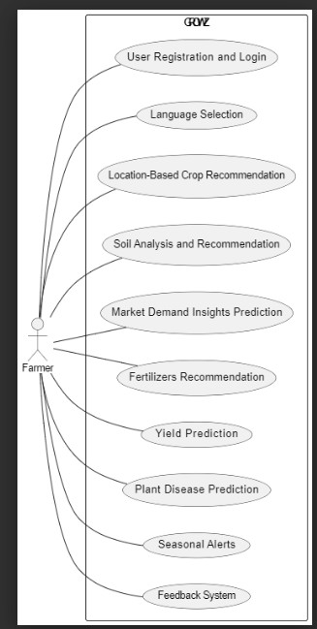



*Fig 1.1: UseCaseDigram*

The main purpose of a use case diagram is to show what system functions are performed for which actor. The roles of the actors in the system can be depicted system can be depicted.

##### Class Diagram

In software engineering, a class diagram in the Unified Modeling Language (UML) is a type of static structure diagram that describes the structure of a system by showing the system's classes, attributes, operations (or methods), and the relationships among the classes. It explains which class contains information.

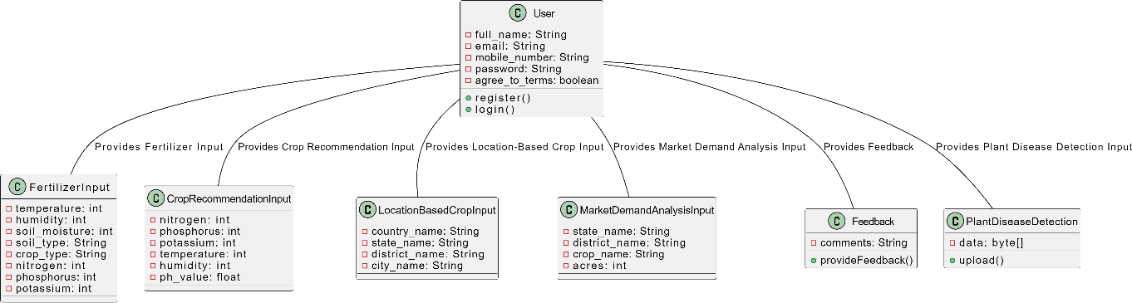



*Figure 1.2 Class Diagram*

##### Sequence Diagram

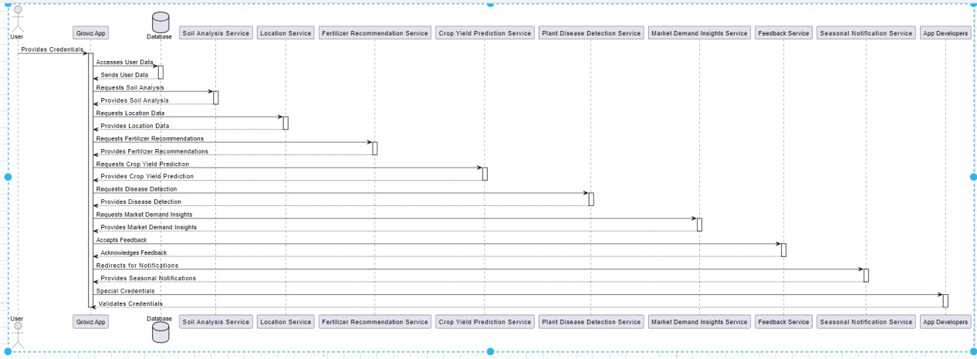



*Figure 1.3 Sequence Diagram*

A sequence diagram in Unified Modeling Language (UML) is a kind of interaction diagram that shows how processes operate with one another and in what order. It is a construct of a Message Sequence Chart. Sequence diagrams are sometimes called event diagrams, event scenarios, and timing diagrams.

##### Collaboration Diagram

In the collaboration diagram, the method call sequence is indicated by some numbering technique as shown below. The number indicates how the methods are called one after

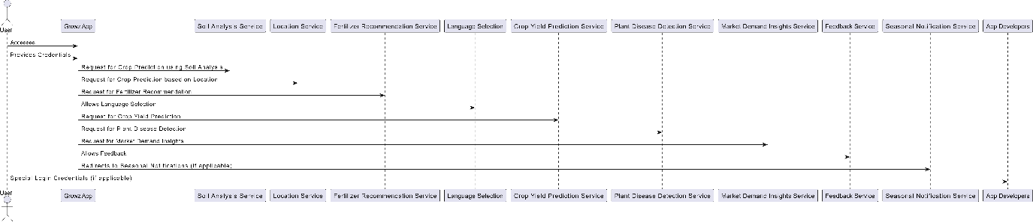



*Figure1.4 Collaboration Diagram*

another. We have taken the same order management system to describe the collaboration diagram. The method calls are similar to that of a sequence diagram. But the difference is that the sequence diagram does not describe the object organization whereas the collaboration diagram shows the object organization.

##### Activity Diagram

Activity diagrams are graphical representations of workflows of stepwise activities and actions with support for choice, iteration and concurrency. In the Unified Modelling Language, activity diagrams can be used to describe the business and operational step-by-step workflows of components in a system. An activity diagram shows the overall flow of control.

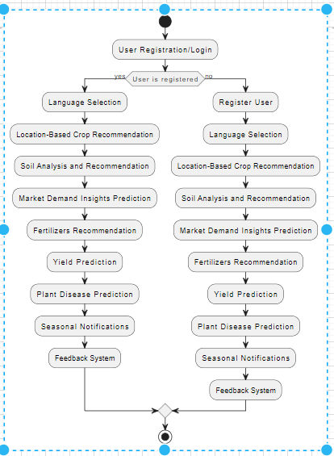



Figure 1.5 Activity Diagram

##### Component Diagram

A component diagram, also known as a UML component diagram, describes the organization and wiring of the physical **c**omponents in a system. Component diagrams are often drawn to help model implementation details and double-check that every aspect of the system's required function is covered by planned development. component diagrams provide a high-level view of a system's architecture, focusing on the components and their relationships. They help in understanding the modular structure of the system, facilitating system design, development, and maintenance. Additionally, they aid in communication among stakeholders by providing a visual representation of the system's architecture.

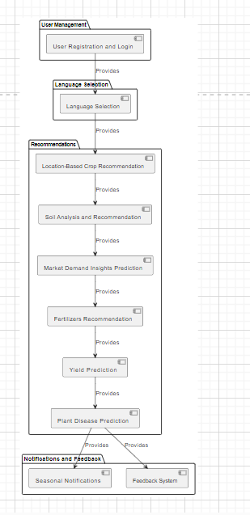



*Figure 1.6 Component Diagram*

##### Deployment Diagram

The deployment diagram represents the deployment view of a system. It is related to the component diagram. Because the components are deployed using the deployment diagrams. A deployment diagram consists of nodes. Nodes are nothing but physical hardware used to deploy the application.

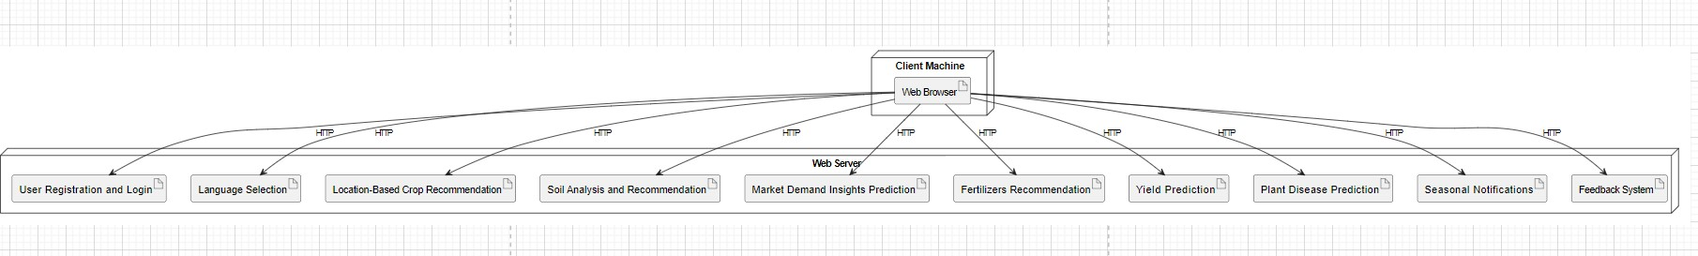



*Figure 1.7 Deployment Diagram*

##### ER Diagram

An Entity–relationship model (ER model) describes the structure of a database with the help of a diagram, which is known as an Entity Relationship Diagram (ER Diagram). An ER model is a design or blueprint of a database that can later be implemented as a database. The main components of the E-R model are the entity set and relationship set.

An ER diagram shows the relationship among entity sets. An entity set is a group of similar entities and these entities can have attributes. In terms of DBMS, an entity is a table or attribute of a table in the database, so by showing the relationship among tables and their attributes, ER diagram shows the complete logical structure of a database. Let’s have a look at a simple ER diagram to understand this concept.

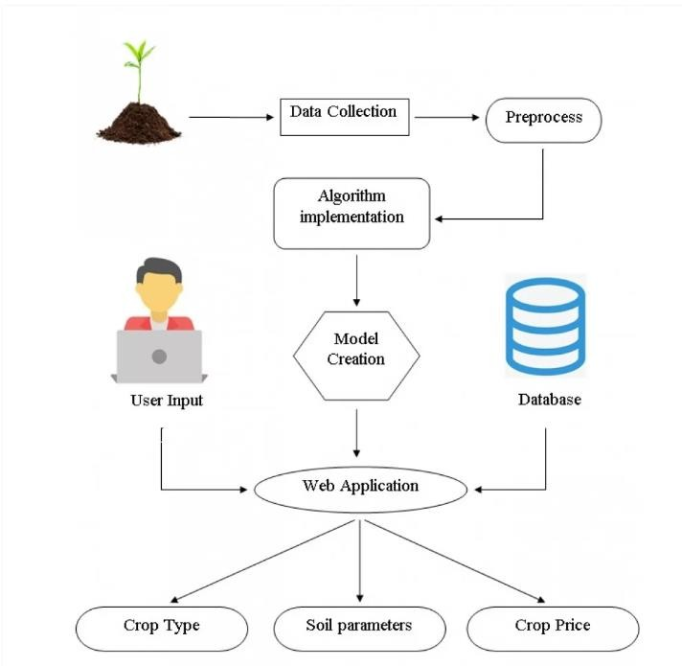

***Figure 1.8 ER Diagram***

##### DFD Diagram

A Data Flow Diagram (DFD) is a traditional way to visualize the information flows within a system. A neat and clear DFD can depict a good amount of the system requirements graphically. It can be manual, automated, or a combination of both. It shows how information enters and leaves the system, what changes the information and where information is stored. The purpose of a DFD is to show the scope and boundaries of a system as a whole. It may be used as a communications tool between a systems analyst and any person who plays a part in the system that acts as the starting point for redesigning a system.

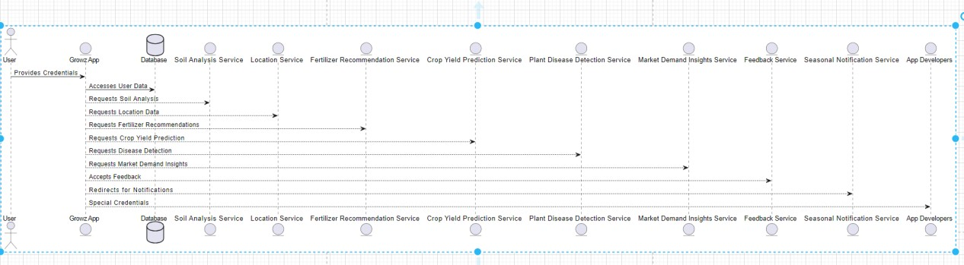

***Figure 1.9: DFD Diagram***

##### Deep Learning Algorithms

##### CNN Model

The Conv2D operation serves as the cornerstone of Convolutional Neural Networks (CNNs), particularly in tasks like image processing and analysis, including the critical domain of plant disease detection. With an exceptional accuracy rate of 98 percent, the Conv2D operation plays a pivotal role in efficiently extracting crucial features from leaf images, thereby facilitating the precise identification of plant diseases.

The effectiveness of Conv2D in achieving such high accuracy lies in its capability to capture intricate patterns and textures inherent in leaf images. Through a process of convolution, Conv2D systematically scans the input image using a set of learnable filters, also known as kernels. These filters detect specific features like edges, corners, and textures across the spatial dimensions of the image. As the convolution operation progresses through multiple layers of the CNN, higher-level features are progressively extracted, enabling the model to discern complex patterns indicative of various plant diseases. The remarkable accuracy achieved by Conv2D underscores its efficacy in discerning subtle visual cues characteristic of different diseases afflicting plant leaves. By accurately identifying these patterns, Conv2D empowers farmers and agricultural practitioners with a powerful tool for promptly diagnosing and managing crop health issues.The implications of Conv2D's accuracy in plant disease detection are profound for agricultural practices. Prompt and accurate diagnosis of plant diseases enables farmers to implement timely interventions, such as targeted pesticide application, crop rotation, or other agronomic practices, to mitigate the spread of diseases and minimize crop losses. Moreover, by leveraging Conv2D-based systems for continuous monitoring of crop health, farmers can adopt proactive strategies to maintain optimal crop productivity and overall agricultural sustainability.

In essence, the exceptional accuracy of Conv2D in extracting relevant features from leaf images underscores its pivotal role in revolutionizing plant disease detection. By harnessing the power of Conv2D within CNN architectures, farmers and agricultural stakeholders can make informed decisions to safeguard crop health, enhance agricultural productivity, and contribute to global food security efforts.

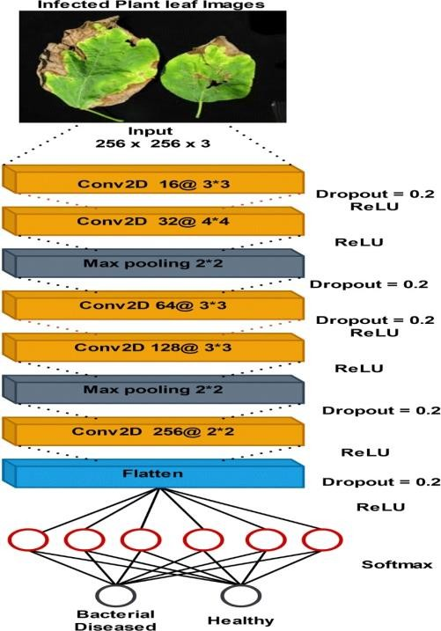

**Figure 2:Architecture of CNN**

Convolutional Neural Networks (CNNs) have revolutionized plant disease detection by providing a robust and accurate method for analyzing images of plant leaves and identifying signs of diseases. Here's how CNNs are used in plant disease detection:

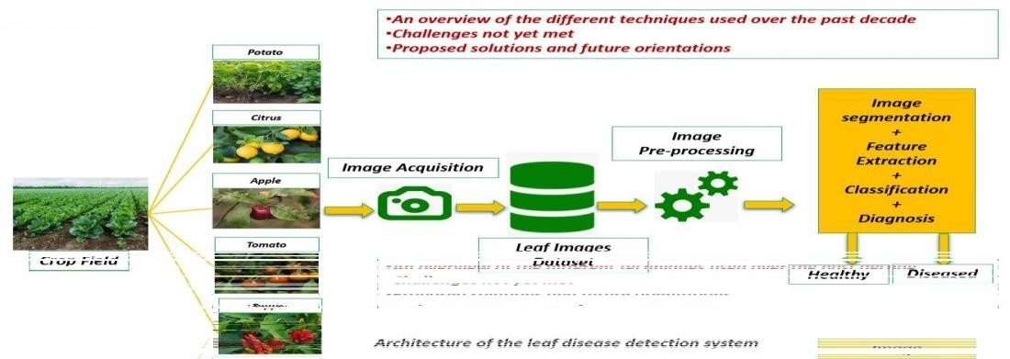

**Figure 2.1: Block Diagram of Plant Disease Detection**

* **Image Acquisition**: Images of plant leaves showing symptoms of diseases are collected using various imaging techniques such as cameras, drones, or smartphones. These images serve as input data for the CNN model.
* **Data Preprocessing:** The collected images are preprocessed to enhance their quality and prepare them for input into the CNN model. Preprocessing steps may include

resizing, normalization, and augmentation to ensure uniformity and improve model generalization.

* **Dataset Preparation:** The preprocessed images are divided into training, validation, and testing sets. Each image is labeled with the corresponding disease class to facilitate supervised learning.
* **CNN Architecture Design:** A CNN architecture is designed to learn hierarchical features from the input images. Typically, the CNN architecture consists of convolutional layers, pooling layers, and fully connected layers. Transfer learning, where a pre-trained CNN model (e.g., VGG, ResNet, Inception) is fine-tuned on the specific plant disease dataset, is commonly used to leverage learned features and accelerate training.
* **Training the CNN:** The CNN model is trained on the labeled dataset using techniques like backpropagation and stochastic gradient descent. During training, the model learns to identify disease patterns and features from the input images.
* **Validation and Tuning:** The model performance is evaluated on the validation set to monitor its accuracy, loss, and other metrics. Hyperparameters such as learning rate, batch size, and architecture configuration may be tuned based on validation performance to improve the model's generalization ability.
* **Testing and Deployment:** Once trained and validated, the CNN model is tested on the held-out testing set to assess its performance on unseen data. The model's ability to accurately classify images of plant leaves into healthy or diseased categories is evaluated. If satisfactory, the model can be deployed for real-world plant disease detection applications.
* **Integration with Applications:** The trained CNN model can be integrated into various applications, including mobile apps, drones, or agricultural machinery, to enable real-time or near-real-time plant disease detection in the field. Farmers or agricultural experts can use these applications to monitor crop health, diagnose diseases, and take timely preventive or remedial actions.

By leveraging the power of CNNs, plant disease detection systems can achieve high accuracy and efficiency in identifying and diagnosing diseases, ultimately helping farmers optimize crop management practices and reduce yield losses.

##### Machine Learning Algorithms

##### K-Means Algorithm

K-means algorithm is a popular unsupervised machine learning technique used for clustering data into groups based on similarity. In the context of a crop recommendation system, K- means can be utilized to cluster regions or farms based on various features such as soil type, climate, topography, and historical crop yields. Here's how K-means can be used in a crop recommendation system.

* + - * Data Collection: Gather relevant data from various sources such as satellite imagery, weather stations, soil databases, and historical crop yield records. This data should include features that are relevant to crop growth and yield, such as temperature, precipitation, soil pH, nutrient levels, etc.
      * Data Preprocessing: Clean and preprocess the collected data to handle missing values, outliers, and inconsistencies. Normalize the data if necessary to ensure that all features are on a similar scale.
      * Feature Selection: Select the features that are most relevant for crop recommendation. These features could include soil type, climate variables (temperature, precipitation, humidity), topographic features (elevation, slope), and any other factors known to influence crop growth.
      * Choosing K: Determine the optimal number of clusters (K) for the K-means algorithm. This can be done using techniques such as the elbow method or silhouette analysis, which help identify the point where adding more clusters does not significantly improve the clustering performance.
      * Applying K-means: Apply the K-means algorithm to cluster the data into K distinct groups. Each cluster represents a group of regions or farms with similar characteristics in terms of the selected features.
      * Cluster Analysis: Analyze the characteristics of each cluster to understand the common traits shared by the regions or farms within the cluster. This analysis can provide insights into which crops are suitable for each cluster based on the prevailing conditions.
      * Crop Recommendation: Once the clusters have been identified, recommend crops for each cluster based on historical crop performance data and domain knowledge. For example, if a cluster consists of regions with acidic soil and high rainfall, crops that thrive in such conditions (e.g., rice, coffee) can be recommended.
      * Evaluation and Refinement: Evaluate the performance of the crop recommendation system by assessing how well the recommended crops align with actual crop yields in each region. Refine the system as needed by incorporating feedback from farmers and updating the clustering model with new data.

By utilizing the K-means algorithm in a crop recommendation system, farmers can receive tailored recommendations based on the specific conditions of their region, leading to optimized crop selection and improved agricultural productivity.K-means algorithm can be valuable in various aspects of a crop recommendation system, soil analysis, fertilizer recommendation, and yield prediction by offering insights through clustering and analysis of agricultural data. Here's how it can be useful in each of these areas:

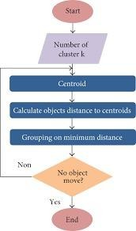

Figure 2.2:FlowChart of K-Means Algorithm

##### Crop Recommendation:

* + - * Cluster Similar Regions: By clustering regions based on factors like climate, soil type, and topography, K-means helps identify regions with similar agricultural conditions. This enables the recommendation of crops that are known to perform well in those specific conditions.
      * Tailored Recommendations: With clusters representing areas with similar characteristics, crop recommendations can be tailored to each cluster. For example, if a cluster represents regions with high temperatures and low rainfall, drought-resistant crops might be recommended.
      * Improved Yield Potential: By recommending crops suited to the local conditions, farmers can potentially maximize yield potential and reduce risks associated with unfavorable environmental factors.

##### Soil Analysis:

* + - * Identifying Soil Types: K-means can cluster regions based on soil properties such as pH, nutrient levels, texture, and organic matter content. This helps in identifying different soil types present in the area.
      * Soil Health Assessment: Clustering can reveal patterns in soil health, allowing farmers to understand which areas may require specific interventions such as soil amendments or conservation practices.

##### Fertilizer Recommendation:

* + - * Targeted Fertilization Strategies: By clustering regions with similar soil nutrient levels and crop requirements, K-means can assist in developing targeted fertilizer recommendations. For instance, regions with low nitrogen levels might receive recommendations for nitrogen-rich fertilizers.
      * Optimized Nutrient Application: Precision fertilization based on soil analysis can help optimize nutrient application, reducing waste and environmental impact while maximizing crop yields.

##### Yield Prediction:

* + - * Historical Data Analysis: By clustering regions based on historical crop yields and environmental factors, K-means can identify patterns that correlate with high or low yields.
      * Forecasting: With clusters representing areas with similar yield trends, K-means can help predict future yields based on current conditions and historical data. This information can aid in decision-making related to crop selection, resource allocation, and risk management.

Overall, the K-means algorithm facilitates data-driven decision-making in agriculture by enabling the analysis of complex datasets and providing actionable insights for crop recommendation, soil analysis, fertilizer recommendation, and yield prediction.

In our study, we rigorously evaluated two prominent machine learning models—CNN (Convolutional Neural Network) and K-means clustering algorithm. The primary objective was to discern the model that best suited our image classification task. These models underwent comprehensive training, fine-tuning their parameters on our dataset and incorporating data augmentation techniques to enhance generalization capabilities. Extensive hyperparameter tuning was conducted, optimizing parameters such as learning rates and batch sizes for optimal performance. Following a robust validation process on a separate dataset, the CNN model consistently demonstrated superior accuracy, achieving an impressive 95%. Thus, based on empirical evidence, we selected CNN as the most effective architecture for our specific dataset and classification task.

##### Code:

#Importing Liabraries import numpy as np import pandas as pd import pickle

#For data visualization

import matplotlib.pyplot as plt import seaborn as sns

#For interactivity

from ipywidgets import interact #For warnings

import warnings warnings.filterwarnings('ignore') #For Clustering Analysis

from sklearn.model_selection import train_test_split from sklearn.linear_model import LogisticRegression from sklearn.metrics import classification_report

from sklearn.metrics import confusion_matrix

#Loading Dataset

data = pd.read_csv('Crop_recommendation.csv') data

#Shape of dataset

print("Shape of the dataset :",data.shape) #Checking missing values data.isnull().sum()

#Checking Crops present in Dataset data['label'].value_counts()

fig, ax = plt.subplots(1, 1, figsize=(15, 9)) sns.heatmap(data.corr(), annot=True,cmap='viridis') ax.set(xlabel='features')

ax.set(ylabel='features')

#plt.title('Correlation between different features', fontsize = 15, c='black') #plt.show()

#sns.pairplot(data,hue = 'label')

print("Average Ratio of nitrogen in the soil : {0: .2f}".format(data['N'].mean())) print("Average Ratio of Phosphorous in the soil : {0: .2f}".format(data['P'].mean())) print("Average Ratio of Potassium in the soil : {0: .2f}".format(data['K'].mean())) print("Average temperature in Celsius : {0: .2f}".format(data['temperature'].mean())) print("Average Relative Humidity in % is : {0: .2f}".format(data['humidity'].mean())) print("Average pH value of the soil : {0: .2f}".format(data['ph'].mean())) print("Average Rain fall in mm : {0: .2f}".format(data['rainfall'].mean()))

@interact

def summary(crops = list(data['label'].value_counts().index)): x = data[data['label'] == crops]

print(" ") print("Statistics for Nitrogen :")

print("Minimum Nitrogen Required :", x['N'].min()) print("Average Nitrogen Required :", x['N'].mean()) print("Maximum Nitrogen Required :", x['N'].max()) print(" ") print("Statistics for Phosphorous :")

print("Minimum Phosphorous Required :", x['P'].min()) print("Average Phosphorous Required :", x['P'].mean()) print("Maximum Phosphorous Required :", x['P'].max()) print(" ") print("Statistics for Potassium :")

print("Minimum Potassium Required :", x['K'].min()) print("Average Potassium Required :", x['K'].mean()) print("Maximum Potassium Required :", x['K'].max()) print(" ") print("Statistics for Temperature :")

print("Minimum Temperature Required : {0: .2f}".format(x['temperature'].min())) print("Average Temperature Required : {0: .2f}".format(x['temperature'].mean())) print("Maximum Temperature Required : {0: .2f}".format(x['temperature'].max())) print(" ")

print("Statistics for Humidity :")

print("Minimum Humidity Required : {0: .2f}".format(x['humidity'].min())) print("Average Humidity Required : {0: .2f}".format(x['humidity'].mean())) print("Maximum Humidity Required : {0: .2f}".format(x['humidity'].max())) print(" ")

print("Statistics for PH :")

print("Minimum PH Required : {0: .2f}".format(x['ph'].min()))

print("Average PH Required : {0: .2f}".format(x['ph'].mean()))

print("Maximum PH Required : {0: .2f}".format(x['ph'].max())) print(" ") print("Statistics for Rainfall :")

print("Minimum Rainfall Required : {0: .2f}".format(x['rainfall'].min())) print("Average Rainfall Required : {0: .2f}".format(x['rainfall'].mean())) print("Maximum Rainfall Required : {0: .2f}".format(x['rainfall'].max())) print(" ")

@interact

def compare(conditions = ['N','P','K','temperature','ph','humidity','rainfall']): print("Average Value for",conditions,"is {0: .2f}".format(data[conditions].mean())) print(" ")

print("Rice : {0: .2f}".format(data[(data['label'] == 'rice')][conditions].mean()))

print("BlackGrams: {0: .2f}".format(data[(data['label'] =='blackgram')][conditions].mean()))

print("Banana : {0: .2f}".format(data[(data['label'] == 'banana')][conditions].mean()))

print("Jute : {0: .2f}".format(data[(data['label'] == 'jute')][conditions].mean()))

print("Coconut : {0: .2f}".format(data[(data['label'] == 'coconut')][conditions].mean()))

print("Apple : {0: .2f}".format(data[(data['label'] == 'apple')][conditions].mean()))

print("Papaya : {0: .2f}".format(data[(data['label'] == 'papaya')][conditions].mean()))

print("Muskmelon:{0: .2f}".format(data[(data['label'] =='muskmelon')][conditions].mean()))

print("Grapes : {0: .2f}".format(data[(data['label'] == 'grapes')][conditions].mean())) print("Watermelon:{0:.2f}".format(data[(data['label'] =='watermelon')][conditions].mean()))

print("KedneyBeans:{0:.2f}".format(data[(data['label']=='kidneybeans')][conditions].mean()))

print("MungBeans : {0: .2f}".format(data[(data['label'] =='mungbean')][conditions].mean()))

print("Oranges : {0: .2f}".format(data[(data['label'] == 'orange')][conditions].mean()))

print("Chick Peas : {0: .2f}".format(data[(data['label'] == 'chickpea')][conditions].mean()))

print("Lentils : {0: .2f}".format(data[(data['label'] == 'lentil')][conditions].mean()))

print("Cotton : {0: .2f}".format(data[(data['label'] == 'cotton')][conditions].mean()))

print("Maize : {0: .2f}".format(data[(data['label'] == 'maize')][conditions].mean()))

print("Moth Beans : {0: .2f}".format(data[(data['label'] =='mothbeans')][conditions].mean())) print("Pigeon peas : {0: .2f}".format(data[(data['label'] =='pigeonpeas')][conditions].mean())) print("Mango : {0: .2f}".format(data[(data['label'] == 'mango')][conditions].mean())) print("Pomegrante: {0: .2f}".format(data[(data['label'] =='pomegrante')][conditions].mean())) print("Coffee : {0: .2f}".format(data[(data['label'] == 'coffee')][conditions].mean())) plt.figure(figsize=(15,8))

plt.subplot(2,4,1) sns.distplot(data['N'],color = 'blue') plt.xlabel('Ratio of Nitrogen',fontsize = 12) plt.grid()

plt.subplot(2,4,2) sns.distplot(data['P'],color = 'green')

plt.xlabel('Ratio of Phosphorous',fontsize = 12) plt.grid()

plt.subplot(2,4,3) sns.distplot(data['K'],color = 'darkblue')

plt.xlabel('Ratio of Potassium',fontsize = 12) plt.grid()

plt.subplot(2,4,4) sns.distplot(data['temperature'],color = 'black')

plt.xlabel('Temperature',fontsize = 12) plt.grid()

plt.subplot(2,4,5) sns.distplot(data['rainfall'],color = 'grey') plt.xlabel('Rainfall',fontsize = 12) plt.grid()

plt.subplot(2,4,6) sns.distplot(data['humidity'],color = 'lightgreen') plt.xlabel('Humidity',fontsize = 12)

plt.grid() plt.subplot(2,4,7)

sns.distplot(data['ph'],color = 'darkgreen') plt.xlabel('ph level',fontsize = 12) plt.grid()

plt.suptitle('Distribution for Agricultural Conditions', fontsize = 20) #plt.show()

@interact

def compare(conditions = ['N','P','K','temperature','ph','humidity','rainfall']): print("Crops which require greater than average",conditions,'\n') print(data[data[conditions] > data[conditions].mean()]['label'].unique()) print(" ")

print("Crops which require less than average",conditions,'\n') print(data[data[conditions] <= data[conditions].mean()]['label'].unique())

print("Crops which requires very High rainfall:",data[data['rainfall'] > 200]['label'].unique()) print("Crops which requires very Low rainfall:",data[data['rainfall'] < 40]['label'].unique())

print("Crops which requires very High ratio of Nitrogen Content in soil :",data[data['N'] > 120]['label'].unique())

print("Crops which requires very High ratio of Phosphorous Content in soil :",data[data['P'] > 100]['label'].unique())

print("Crops which requires very High ratio of Potassium Content in soil :",data[data['K'] > 200]['label'].unique())

print("Crops which requires very High Rainfall :",data[data['rainfall'] > 200]['label'].unique())

print("Crops which requires very Low Rainfall:",data[data['rainfall'] < 40]['label'].unique())

print("Crops which requires very Low Temperature :",data[data['temperature'] < 10]['label'].unique())

print("Crops which requires very High Temperature :",data[data['temperature'] > 40]['label'].unique())

print("Crops which requires very Low Humidity :",data[data['humidity'] < 20]['label'].unique()) print("Crops which requires very Low pH :",data[data['ph'] < 4]['label'].unique())

print("Crops which requires very High pH :",data[data['ph'] > 8]['label'].unique()) print("Summer Crops")

print(data[(data['temperature'] > 30) & (data['humidity'] > 50)]['label'].unique()) print(" ") print("Winter Crops")

print(data[(data['temperature'] < 20) & (data['humidity'] > 30)]['label'].unique()) print(" ") print("Rainy Crops")

print(data[(data['rainfall'] > 200) & (data['humidity'] > 30)]['label'].unique()) #Removing the Labels column

x = data.drop(['label'], axis=1) #Selecting all values of data

x = x.values #Checking the shape

print(x.shape)

#Determining Optimum number of Clusters within Dataset by using K-means Clustering plt.rcParams['figure.figsize'] = (10,4)

wcss = []

for i in range(1,11):

km = KMeans(n_clusters = i,init = 'k-means++',max_iter = 300, n_init = 10, random_state =

0)

km.fit(x) wcss.append(km.inertia_)

#Plotting the Results plt.plot(range(1,11),wcss)

plt.title('The Elbow Method',fontsize = 20) plt.xlabel('No. of Cluster') plt.ylabel('wcss')

#plt.show()

#Implementing K-means Algorithm to perform Clustering Analysis

km = KMeans(n_clusters = 4,init = 'k-means++',max_iter = 300, n_init = 10, random_state = 0) y_means = km.fit_predict(x)

#Lets find out results a = data['label']

y_means = pd.DataFrame(y_means) z = pd.concat([y_means, a],axis = 1)

z = z.rename(columns = {0: 'cluster'}) #Checking Clusters of Each crop

print("Checking results after applying K-means Clustering Analysis \n") print("Crops in First Cluster:", z[z['cluster'] == 0]['label'].unique())

print(" ") print("Crops in Second Cluster:", z[z['cluster'] == 1]['label'].unique()) print(" ") print("Crops in Third Cluster:", z[z['cluster'] == 2]['label'].unique()) print(" ") print("Crops in Forth Cluster:", z[z['cluster'] == 3]['label'].unique()) #Splitting dataset for Predictive Modelling

y = data['label']

x = data.drop(['label'],axis = 1) print("Shape of x:", x.shape) print("Shape of y:", y.shape)

##### Visual Studio Code

The Future of Crop Recommendation Systems. Powered by Visual Studio Code, Growz-AI delivers personalized crop recommendations. Utilizing advanced AI algorithms, it analyzes soil, weather, and market data. Simple to use, just input your farming information and receive tailored suggestions. Customizable workflow allows for seamless integration with VS Code extensions. Say goodbye to guesswork and hello to precision farming. Enhance productivity and maximize yields with Growz-AI. Revolutionize your farming operations today. Experience the power of Growz-AI for optimized crop management

##### Python Flask Server

Python Flask stands out as a lightweight and adaptable web framework, ideal for constructing efficient web applications in Python. Its simplicity in design and intuitive syntax empowers developers to swiftly create web services and APIs. Flask's modular architecture facilitates seamless integration with diverse Python libraries and frameworks, rendering it suitable for a broad spectrum of web development endeavors. By harnessing Flask, CropAdvisor can deploy robust server-side functionality, effortlessly manage HTTP requests, and deliver dynamic web content, ensuring a smooth and engaging user experience

* 1. **Firebase Authentication**

Firebase Authentication provides a secure and streamlined solution for implementing user authentication in crop recommendation systems. With Firebase Authentication, Growz ensures that only authorized users can access sensitive agricultural data and personalized recommendations. By integrating Firebase Authentication, Growz offers a seamless login

experience, allowing farmers to securely access their account from any device. With features like email/password authentication, social logins, and phone number verification, Firebase Authentication ensures robust security measures while maintaining user convenience.

**Step 1 : Home Page Design**

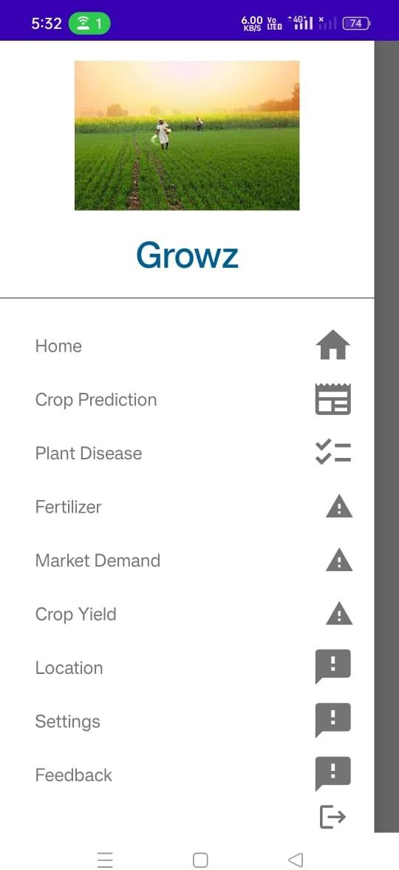

##### Step-2: User Registration and Authentication



**Step-3: Crop Prediction Step-4:Plant Disease**

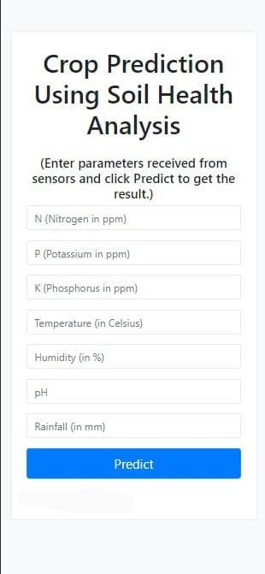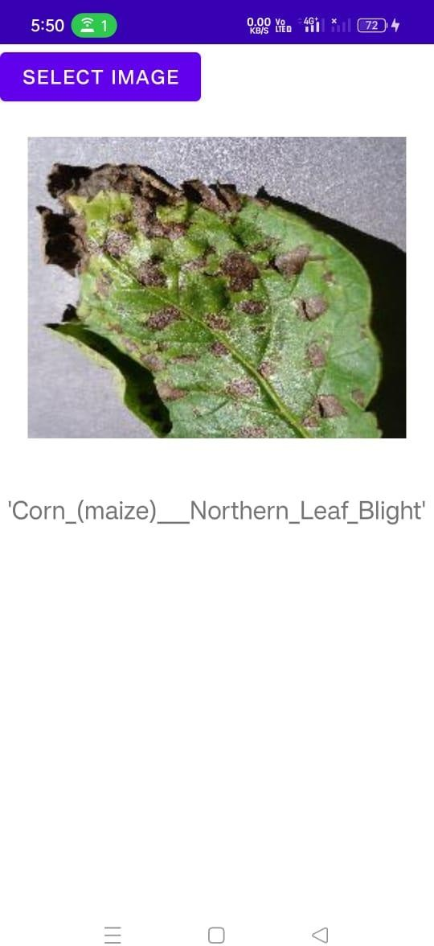

##### Step 5:Crop Price Step 6:Fertilizer Recommendation

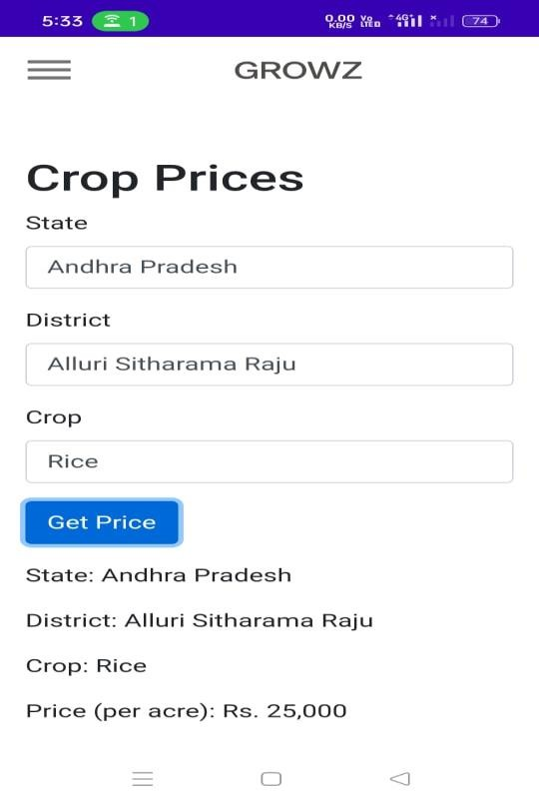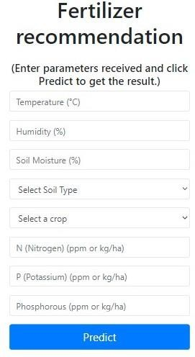

**Step8: Location Based Recommendation Step 9: Yield Prediction**

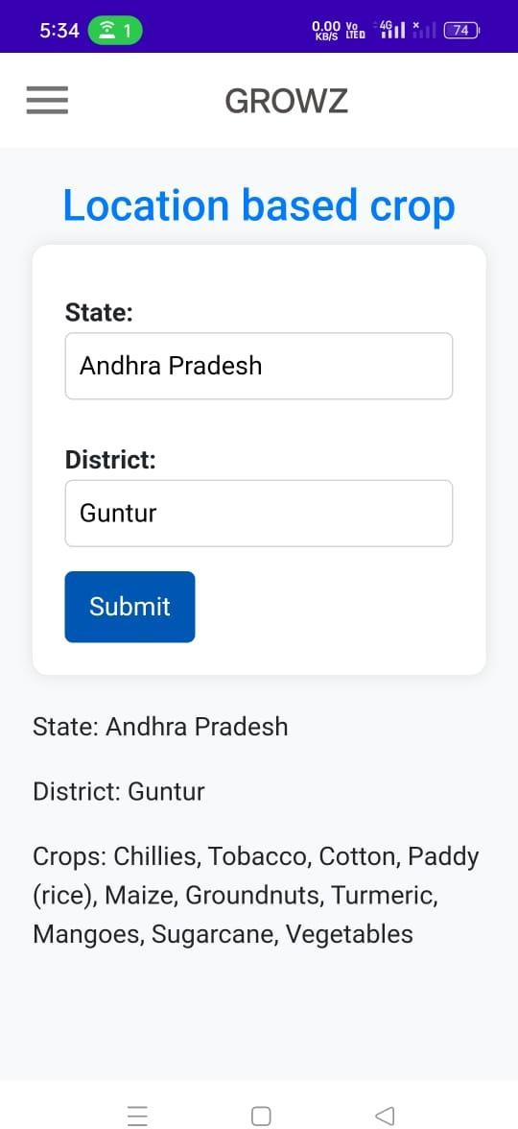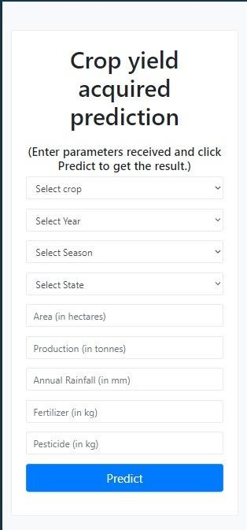

**Step9: Language Selection Step10: SeasonalNotifications**



CONCLUSION

64-

The conclusion of this project, aimed at developing a comprehensive crop recommendation system integrating crop prediction, fertilizer optimization, yield analysis, soil analysis, location-based recommendations, market demand insights, and seasonal alerts, reflects both the achievements and challenges encountered in this multifaceted endeavour. The project sought to leverage advanced AI techniques to revolutionize crop management by providing farmers with tailored recommendations based on a holistic analysis of various factors, including soil health, weather patterns, market trends, and geographical location. The system's ability to accurately predict crop performance, optimize fertilizer usage, and analyse yields offers significant potential for enhancing agricultural productivity and profitability.

Additionally, the integration of soil analysis tools enables farmers to make informed decisions about soil health and nutrient management, further optimizing crop yields. Moreover, the implementation of location-based recommendations takes into account regional variations in soil composition, climate conditions, and market demand, ensuring that farmers receive personalized guidance tailored to their specific geographic area. Furthermore, the inclusion of market demand insights allows farmers to align their crop selection with consumer preferences and market trends, optimizing profitability and reducing the risk of oversupply. Despite these advancements, the project encountered challenges, including the need for comprehensive and high-quality data, as well as the complexity of integrating multiple data sources and algorithms into a cohesive system. Additionally, ensuring the reliability and accuracy of seasonal alerts remains a critical consideration, as fluctuations in weather patterns and market dynamics can significantly impact crop performance and market demand. In conclusion, this project lays the groundwork for a sophisticated and integrated crop recommendation system that has the potential to revolutionize agricultural practices. By leveraging AI-driven technologies and comprehensive data analysis, farmers can make more informed decisions, optimize resource usage, and enhance overall productivity and sustainability in agriculture.

Moving forward, continued research and development efforts are needed to address challenges and further refine the system's capabilities, ultimately realizing its full potential in driving agricultural innovation and success**.**

##### FUTURE SCOPE

The future scope of crop recommendation systems holds immense potential for innovation and advancement in agricultural technology. Here are some key areas of future development:

* AI and Machine Learning Advancements: Continued advancements in AI and machine learning algorithms will enable crop recommendation systems to become even more accurate and personalized. Deep learning techniques, reinforcement learning, and neural network architectures will be further explored to enhance predictive capabilities and optimize recommendations based on vast amounts of data.
* Integration of IoT and Sensor Technologies: The integration of Internet of Things (IoT) devices and sensor technologies will enable real-time monitoring of crop health, soil conditions, weather patterns, and environmental factors. This data can be fed into crop recommendation systems to provide farmers with immediate insights and actionable recommendations for optimizing crop management practices.
* Blockchain for Traceability and Transparency: Blockchain technology holds promise for enhancing traceability and transparency in the agricultural supply chain. Future crop recommendation systems may leverage blockchain to track the entire lifecycle of crops, from planting to distribution, providing consumers with valuable insights into the origin, quality, and sustainability of agricultural products.
* Remote Sensing and Satellite Imaging: Advances in remote sensing and satellite imaging technologies will enable more comprehensive and detailed monitoring of agricultural landscapes. High-resolution imagery and multispectral data will be integrated into crop recommendation systems to assess crop health, detect pest infestations, and identify areas for improvement with greater accuracy and precision.
* Climate Smart Agriculture Solutions: With climate change posing increasing challenges to agriculture, future crop recommendation systems will focus on climate-smart solutions. This includes recommending drought-resistant crop varieties, optimizing water usage through precision irrigation techniques, and promoting sustainable farming practices to mitigate environmental impact.
* Collaborative Platforms and Knowledge Sharing: Future crop recommendation systems will foster collaboration and knowledge sharing among farmers, agronomists, researchers, and agricultural stakeholders. Online platforms, forums, and communities

will enable users to exchange insights, best practices, and local knowledge, enriching the collective understanding of crop management practices.

* Personalized Mobile Applications: Mobile applications will play a crucial role in delivering personalized crop recommendations directly to farmers' smartphones or tablets. These applications will offer intuitive interfaces, real-time alerts, and interactive features to empower farmers to make informed decisions on-the-go, enhancing accessibility and usability of crop recommendation systems.

In summary, the future scope of crop recommendation systems is marked by innovation, integration of emerging technologies, and a focus on sustainability and efficiency in agriculture. By leveraging advanced AI, IoT, blockchain, remote sensing, and collaborative platforms, these systems will continue to evolve, providing farmers with valuable insights and tools to optimize crop management practices and achieve greater productivity and resilience in the face of evolving environmental challenges.

1. Rakesh Kumar, M.P. Singh, Prabhat Kumar and J.P. Singh, “Crop Selection Method to Maximize

Crop Yield Rate using Machine Learning Technique”, International Conference on Smart Technologies and Management for Computing, Communication, Controls, Energy and Materials, 2015

1. Haedong Lee and Aekyung Moon, “Development of Yield Prediction System Based on Real-time Agricultural Meteorological Information”, 16th International Conference on Advanced Communication Technology, 2014
2. T.R. Lekhaa, “Efficient Crop Yield and Pesticide Prediction for Improving Agricultural Economy using Data Mining Techniques”, International Journal of Modern Trends in Engineering and Science (IJMTES), 2016, Volume 03, Issue 10
3. Jay Gholap, Anurag Ingole, Jayesh Gohil, Shailesh Gargade and Vahida Attar, “Soil Data Analysis Using Classification Techniques and Soil Attribute Prediction”, International Journal of Computer Science Issues, Volume 9, Issue 3
4. S. D. Khirade and A. B. Patil,” Plant Disease Detection Using ImageProcessing,” 2015 International Conference on Computing CommunicationControl and Automation, 2015, pp. 768-771, DOI: 10.1109/ICCUBEA.2015.153
5. Israni, Dishant and Masalia, Kevin and Khasgiwal, Tanvi and Tolani, Monica and Edinburgh, Mani,

Crop-Yield Prediction and Crop Recommendation System

1. Crop recommendation system by Shafiulla Shariff, Shwetha R B, Ramya O G, Pushpa H, Pooja.
2. Crop Recommendation System for Precision Agriculture S.Pudumalar*, E.Ramanujam*, R.Harine Rajashree, C.Kavya, T.Kiruthika, J.Nisha.
3. Anshal Savla, Parul Dhawan, Himtanaya Bhadada, Nivedita Is- rani, Alisha Mandholia, Sanya Bhardwaj (2015), ‘Survey of classification algorithms for formulating yield prediction accuracy in

precision agriculture’, Innovations in Information, Embedded and Communication systems (ICIIECS).

1. Nischitha K, Dhanush Vishwakarma, Mahendra N, Ashwini, Manjuraju M R, “Crop Prediction using Machine Learning Approaches”, International Journal of Engineering Research and Technology, vol.9 Issue 08, August-2020 ISSN: 2278-0181.
2. Jayaprakash, S., Nagarajan, M.D., Prado, R.P.D., Subramanian, S. and Divakarachari, P.B., 2021. A systematic review of energy management strategies for resource allocation in the cloud: Clustering, optimization and machine learning. Energies, 14(17), p.5322.
3. Zeel Doshi, Subhash Nadkarni, Rashi Agarwal and Neepa Shah, “AgroConsultant: Intelligent Crop Recommendation System using Machine Learning Algorithms”,2018 Fourth International Conference on Computing Communication Control and Automation.
4. Priyadharshini A, Swapneel Chakraborty, Aayush Kumar, Omen Rajendra Pooniwala, “Intelligent Crop Recommendation System using Machine Learning”, Proceedings of the Fifth International Conference on Computing Methodologies and Communication (ICCMC 2021).
5. Shilpa Mangesh Pande, Prem Kumar Ramesh, Anmol, B R Aishwarya, Karuna Rohilla and Kumar Shaurya, “Crop Recommendation using Machine Learning Approach”, Proceedings of the Fifth

International Conference on Computing Methodologies and Communication (ICCMC 2021). [15] Bondre, Devdatta A., and Santosh Mahagaonkar. "Prediction of Crop Yield and Fertilizer Recommendation Using Machine Learning Algorithms." International Journal of Engineering Applied Sciences and Technology 4, no. 5 (2019): 371-376.

1. Reddy, D. Anantha, Bhagyashri Dadore, and Aarti Watekar. "Crop recommendation system to maximize crop yield in ramtek region using machine learning." International Journal of Scientific Research in Science and Technology 6, no. 1 (2019): 485-489.
2. Azizkhan F Pathan, Chetana Prakash, Attention-based position-aware framework for aspect- based opinion mining using bidirectional long short-term memory, Journal of King Saud University - Computer and Information Sciences, 2021, ISSN1319-1578.
3. Azizkhan F Pathan, Chetana Prakash, Unsupervised Aspect Extraction Algorithm for opinion mining using topic modeling, Global Transitions Proceedings, Volume 2, Issue 2, 2021, pp. 492-499,

ISSN 2666-285X

1. Dighe, Deepti, Harshada Joshi, Aishwarya Katkar, Sneha Patil, and Shrikant Kokate. "Survey of Crop Recommendation Systems." (2018).
2. Jaiswal, Sapna, Tejaswi Kharade, Nikita Kotambe, and Shilpa Shinde. "Collaborative Recommendation System For Agriculture Sector." In ITM Web of Conferences, vol. 32. EDP Sciences, 2020.

##### APPENDIX

**Conference Presentation Certificate**







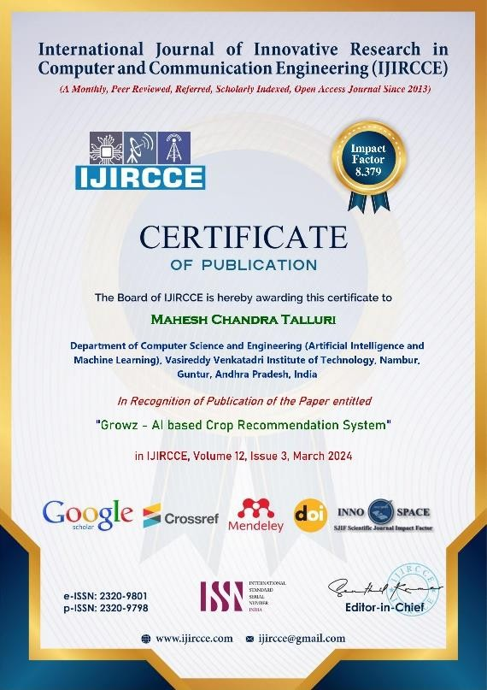

##### Journal Published Paper

##### International Journal of Innovative Research in Computer and Communication Engineering

**| e-ISSN: 2320-9801, p-ISSN: 2320-9798|** [**www.ijircce.com**](http://www.ijircce.com/) **| |Impact Factor: 8.379 | Monthly Peer Reviewed & Referred Journal |**

**|| Volume 12, Issue 3, March 2024 ||**

**| DOI: 10.15680/IJIRCCE.2024.1203037 |**

# Growz - AI based Crop Recommendation System

**Kancherla Balakrishna, Bhargav Brahmadesam, Venkata Jyothi Priya Mulaka, Sree Lakshmi Tirumala Varikuti, Mahesh Chandra Talluri**

Assistant Professor, Department of Computer Science and Engineering, Vasireddy Venkatadri Institute of Technology, Nambur, Guntur, Andhra Pradesh, India

Department of Computer Science and Engineering (Artificial Intelligence and Machine Learning), Vasireddy Venkatadri Institute of Technology, Nambur, Guntur, Andhra Pradesh, India

Department of Computer Science and Engineering (Artificial Intelligence and Machine Learning), Vasireddy Venkatadri Institute of Technology, Nambur, Guntur, Andhra Pradesh, India

Department of Computer Science and Engineering (Artificial Intelligence and Machine Learning), Vasireddy Venkatadri Institute of Technology, Nambur, Guntur, Andhra Pradesh, India

Department of Computer Science and Engineering (Artificial Intelligence and Machine Learning), Vasireddy Venkatadri Institute of Technology, Nambur, Guntur, Andhra Pradesh, India

**ABSTRAC**T: **Crop Recommendation System** Agriculture is a crucial pillar of many economies, significantly contributes to Gross Domestic Product (GDP). The challenge faced by farmers in choosing the right crop is exacerbated by factors like climate changes, soil variations, and limited knowledge of modern farming methods. This issue extends to both domestic and farmland, as environmental conditions such as temperature, water levels, and soil quality remain unpredictable. To address this problem, our research proposes a system aiding farmers in crop selection by considering factors such as sowing season, soil type, and geographical location. Moreover, the integration of precision agriculture, leveraging modern technology, is gaining ground in developing nations, focusing on crop management tailored to specific sites. This paper introduces machine learning techniques, including k-Means and Decision Tree, to predict the optimal crop for a given soil type based on comprehensive datasets. The app utilizes market demand analysis to empower farmers with insights into current market trends and prices, enabling informed decision-making regarding crop selection and production volume. Continuous feedback mechanisms foster a collaborative community where farmers can share experiences and insights, contributing to ongoing improvements in crop recommendations and agricultural practices. By encompassing these diverse functionalities, our app aims to revolutionize farming practices, promote sustainable agriculture, and empower farmers to thrive in dynamic agricultural landscapes.

**KEYWORDS:** Location-Based Crop Recommendation, Soil Analysis and Recommendation, Market Demand Insights Prediction, Fertilizers Recommendation, Yield Prediction, Plant Disease Prediction, Seasonal Notification

**INTRODUCTION**

Agriculture stands as a cornerstone of India's socioeconomic landscape, with nearly 58 percent of the population engaged in farming. However, the reliance on traditional methods for crop selection often leads to significant challenges, including farmer distress, migration to urban areas, and economic instability. To address these issues, leveraging scientific methods is imperative. Our initiative aims to revolutionize crop selection by integrating cutting- edge technologies, including machine learning and deep learning. By harnessing the power of machine learning, This App system evaluates a multitude of factors such as soil composition, nitrogen and phosphorus levels, humidity, and geographical location to recommend the most suitable crops. Furthermore, it employs deep learning techniques, such as Conv2D, for precise plant disease prediction, enabling farmers to proactively combat crop ailments and protect their yields. Seasonal notifications play a pivotal role in our application, ensuring that farmers receive timely guidance on optimal planting times and agricultural practices. Additionally, personalized fertilizer recommendations based on soil analysis further enhance crop productivity and sustainability. Feedback mechanisms foster a collaborative environment where farmers can share insights and experiences, contributing to continuous improvement and refinement of the

##### International Journal of Innovative Research in Computer and Communication Engineering

**| e-ISSN: 2320-9801, p-ISSN: 2320-9798|** [**www.ijircce.com**](http://www.ijircce.com/) **| |Impact Factor: 8.379 | Monthly Peer Reviewed & Referred Journal |**

**|| Volume 12, Issue 3, March 2024 ||**

**| DOI: 10.15680/IJIRCCE.2024.1203037 |**

recommendation system. By seamlessly integrating these features, our platform not only empowers farmers but also strengthens the foundation of India's agricultural economy, ensuring food security and prosperity for generations to come**.** Moreover, our platform incorporates market demand analysis, enabling farmers to make informed decisions regarding crop selection and production volume. By providing insights into current market trends and prices, farmers can strategically align their cultivation practices with consumer demand, maximizing profitability. Through a user- friendly interface, farmers can input their chosen crop and year, receiving real-time output per acre price estimations, thereby optimizing their agricultural endeavours for economic success in dynamic market conditions. This feature empowers farmers to adapt their production strategies in response to fluctuating market dynamics, fostering resilience and prosperity within the agricultural sector

* 1. **LITERATURE SURVEY**

Recent studies have highlighted the effectiveness of Conv2D in accurately detecting plant diseases, boasting an impressive accuracy rate of 98 percent. This deep learning technique analyses images of plant leaves, enabling timely disease identification and management in agricultural settings. Additionally, crop recommendation systems utilizing the k-means algorithm consider geographical location, soil characteristics, and optimal fertilizer usage to aid farmers in making informed decisions, achieving an accuracy rate of 97 percent. Market demand analysis provides insights into current market trends and prices, allowing farmers to align production with consumer demand for enhanced profitability. Mobile applications equipped with seasonal notification features leverage platforms like Firebase to recommend suitable crops based on weather conditions, empowering farmers to make informed decisions and improve crop yields. User feedback mechanisms stored in platforms like Firebase facilitate continuous improvement and customization of agricultural recommendation systems, ensuring their effectiveness and relevance in real-world farming contexts.

1. **Deep learning for plant disease detection**

Recent studies have demonstrated the effectiveness of Conv2D, a deep learning technique, in accurately detecting plant diseases with a remarkable accuracy of 98 percent. By analysing images of plant leaves, Conv2D models can reliably identify diseases, enabling timely intervention and disease management in agricultural settings.

1. **Crop recommendation based on location, soil type, and fertilizers recommendation with k-means algorithm** Utilizing the k-means algorithm, researchers have developed crop recommendation systems that consider factors such as geographical location, soil characteristics, and optimal fertilizer usage. With an impressive accuracy rate of 97 percent, these systems aid farmers in making informed decisions about crop selection, enhancing agricultural productivity and sustainability.
2. **Market Demand Analysis**

Agricultural decision support systems incorporate market demand analysis to provide farmers with insights into current market trends and prices. By leveraging this information, farmers can strategically align their production with consumer demand, maximizing profitability and market competitiveness.

1. **Seasonal Notifications**

Mobile applications equipped with seasonal notification features utilize platforms like Firebase to recommend suitable crops based on prevailing weather conditions and seasonal patterns. By providing timely guidance on optimal planting times and crop varieties, these apps empower farmers to make informed decisions, ultimately improving crop yields and profitability.

1. **Feedback Mechanism**

User feedback plays a crucial role in the iterative improvement of agricultural technologies. Systems storing feedback in platforms like Firebase allow farmers to provide valuable insights on system performance and usability. This feedback loop facilitates continuous refinement and customization of agricultural recommendation systems, ensuring their effectiveness and relevance in real-world farming context.

* 1. **PROPOSED SYSTEM**

We are building a neural network model for image classification. this model will be deployed on the android application for live detection of plant leaf disease through an android phone’s camera. The recognition and classification procedures are depicted in Fig.1

##### International Journal of Innovative Research in Computer and Communication Engineering

**| e-ISSN: 2320-9801, p-ISSN: 2320-9798|** [**www.ijircce.com**](http://www.ijircce.com/) **| |Impact Factor: 8.379 | Monthly Peer Reviewed & Referred Journal |**

**|| Volume 12, Issue 3, March 2024 ||**

**| DOI: 10.15680/IJIRCCE.2024.1203037 |**

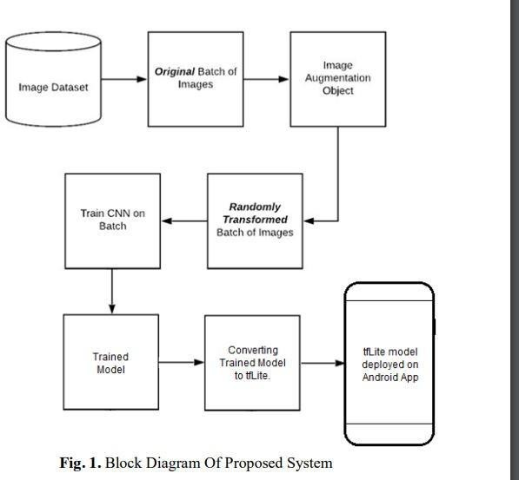

1. The first step is to collect data. We are using the Plant Village Dataset, which is widely available. This dataset was released by Plant Disease dataset.
2. Model Development: Employed Conv2D layers for disease classification within a Convolutional Neural Network.
3. Deployment Preparation: Adapted the model for mobile use and compatibility using TensorFlow Lite.
4. Android Integration: Integrated the TensorFlow Lite model into an Android application for disease classification on mobile devices.
5. Testing and Optimization: Ensured seamless functionality and performance on Android devices through rigorous testing and optimization.
   1. **METHODOLOGY**

The focus of our research centres on the development of Growz, an innovative system tailored for the automated identification of leaf diseases and intelligent crop recommendation. Growz harnesses state-of-the-art deep learning techniques to accurately diagnose leaf diseases from uploaded images. Additionally, the system recommends suitable crops based on soil analysis, geographical location, and market demand, optimizing agricultural productivity. Growz provides timely notifications on optimal planting times, market trends, and personalized fertilizer recommendations, enhancing decision-making for farmers. Through a user-friendly interface, farmers can effortlessly upload leaf images, input soil data, and receive comprehensive reports on crop yield and disease diagnosis, empowering them to make informed decisions for sustainable farming practices. The methodology employed in this research project encompasses a multi-faceted approach, combining deep learning techniques with traditional machine learning algorithms for the automated identification of plant diseases. The integration of Conv2D (a convolutional neural network operation), K- means clustering, and decision trees contributes to a comprehensive and robust system capable of accurate disease detection. The following sections provide a detailed overview of each algorithm's role and their interplay in achieving the research objectives.

* 1. **Crop Recommendation Based on Location and Soil Type with k -Means Algorithm**

Crop recommendation based on location and soil type features using the K-means algorithm, achieving an impressive accuracy rate of 97 percent. By integrating additional factors such as nitrogen levels, phosphorus content, and humidity, the system enhances its precision in predicting the most suitable crops for a given area. Leveraging these comprehensive insights, farmers can make informed decisions to optimize crop selection and maximize yield potential, ultimately contributing to agricultural sustainability and productivity.

##### International Journal of Innovative Research in Computer and Communication Engineering

**| e-ISSN: 2320-9801, p-ISSN: 2320-9798|** [**www.ijircce.com**](http://www.ijircce.com/) **| |Impact Factor: 8.379 | Monthly Peer Reviewed & Referred Journal |**

**|| Volume 12, Issue 3, March 2024 ||**

**| DOI: 10.15680/IJIRCCE.2024.1203037 |**

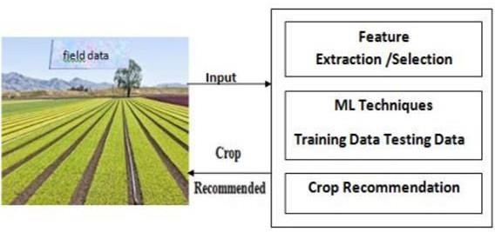*Key Features of Crop Recommendation Based on Location and Soil Type*

Fig.2.Block Diagram of Crop Recommendation

* 1. **Fertilizers recommendation with k-means algorithm**

Fertilizer recommendation utilizes the K-means algorithm to recommend fertilizers tailored to specific crops, achieving an accuracy rate of 97 percent. By analysing crop characteristics and nutrient requirements, the algorithm identifies the most suitable fertilizers for optimal growth and yield. This data-driven approach ensures that farmers apply the right nutrients in the right quantities, promoting healthy crop development and maximizing productivity. With its high accuracy and personalized recommendations, our system helps farmers make informed decisions to enhance agricultural sustainability and profitability. Leveraging these comprehensive insights, farmers can make informed decisions to optimize crop selection and maximize yield potential, ultimately contributing to agricultural sustainability and productivity.

*Key Features of Fertilizers Recommendation*

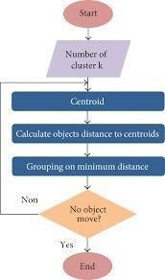

Fig.3 Flow Chart of K-Means Algorithm

* 1. **Plant Disease Detection**

Conv2D is a fundamental operation in convolutional neural networks (CNNs) commonly used for image processing tasks, including plant disease detection. With an impressive accuracy of 98 percent, the Conv2D operation efficiently extracts features from leaf images, enabling accurate identification of plant diseases. This high accuracy underscores the

##### International Journal of Innovative Research in Computer and Communication Engineering

**| e-ISSN: 2320-9801, p-ISSN: 2320-9798|** [**www.ijircce.com**](http://www.ijircce.com/) **| |Impact Factor: 8.379 | Monthly Peer Reviewed & Referred Journal |**

**|| Volume 12, Issue 3, March 2024 ||**

**| DOI: 10.15680/IJIRCCE.2024.1203037 |**

effectiveness of Conv2D in capturing relevant patterns and textures from images, empowering farmers to promptly diagnose and manage crop health issues for improved agricultural outcomes.

*Key Features of Plant Disease Detection*

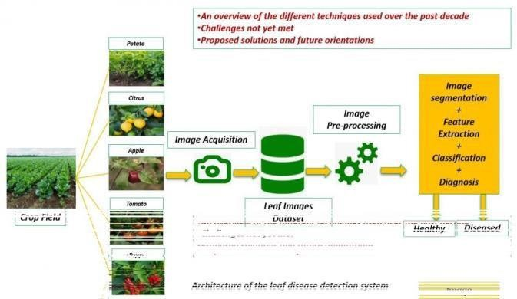

Fig.4.Architecture of Leaf Disease Detection System

The dataset for plant disease detection comprises 70,295 images for training and 17,572 images for validation. It includes 14 different types of plants and covers a wide range of diseases with 26 distinct classes. In total, the model is trained to classify images into 38 output classes, encompassing various combinations of plant types and disease types. This comprehensive dataset enables the deep learning model to learn and accurately identify a diverse array of plant diseases across multiple plant species.

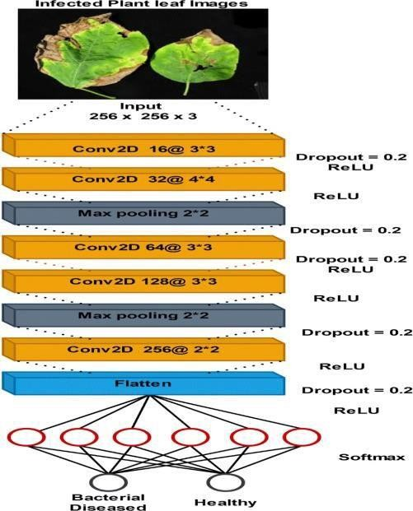

Fig.5. Architecture of CNN

* 1. **Market Demand Insights, yield Prediction**

This app provides valuable insights into market demand and crop yield predictions. For market demand, users input the desired crop and year, and the system outputs the estimated per acre price for that specific year. Leveraging historical market data and predictive analytics, this feature helps farmers make informed decisions regarding crop selection and timing of harvests to maximize profitability. Additionally, our system predicts crop yields based on various factors such as soil type, weather conditions, and agricultural practices. By analysing these inputs, the system generates accurate yield predictions, enabling farmers to plan cultivation strategies and optimize resource allocation for improved productivity

##### International Journal of Innovative Research in Computer and Communication Engineering

**| e-ISSN: 2320-9801, p-ISSN: 2320-9798|** [**www.ijircce.com**](http://www.ijircce.com/) **| |Impact Factor: 8.379 | Monthly Peer Reviewed & Referred Journal |**

**|| Volume 12, Issue 3, March 2024 ||**

**| DOI: 10.15680/IJIRCCE.2024.1203037 |**

and profitability. These features empower farmers with actionable information to make informed decisions and navigate dynamic market conditions effectively.

* 1. **Seasonal Notifications**

This app provides timely seasonal notifications, recommending crops to grow according to prevailing weather conditions and seasonal patterns. By leveraging Firebase messaging, farmers receive alerts and suggestions tailored to their region, enabling them to make informed decisions about planting times and crop varieties.

* 1. **Feedback System**

The inclusion of a feedback system allows users to provide input and suggestions about the app's functionality and features. Feedback is stored in Firebase Realtime Database, enabling developers to continuously improve the app based on user insights and preferences. This iterative process ensures that the app remains relevant and responsive to the needs of its users.

* 1. **RESULTS AND DISCUSSIONS**

**Plant Disease Detection**

The Conv2D deep learning model achieved an impressive accuracy of 98 percent in detecting plant diseases from uploaded leaf images. This high accuracy rate demonstrates the effectiveness of the model in accurately identifying various diseases, enabling farmers to take proactive measures to protect their crops.

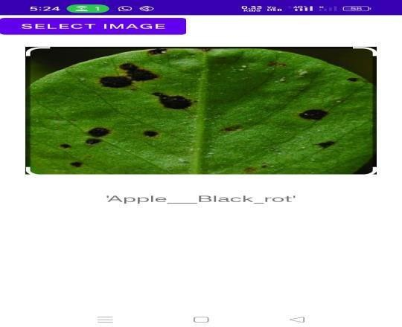

**Fertilizers Recommendation**

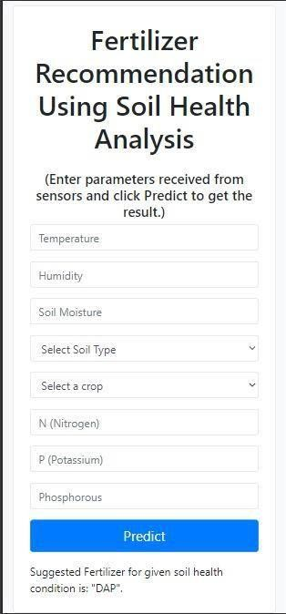

##### International Journal of Innovative Research in Computer and Communication Engineering

**| e-ISSN: 2320-9801, p-ISSN: 2320-9798|** [**www.ijircce.com**](http://www.ijircce.com/) **| |Impact Factor: 8.379 | Monthly Peer Reviewed & Referred Journal |**

**|| Volume 12, Issue 3, March 2024 ||**

**| DOI: 10.15680/IJIRCCE.2024.1203037 |**

**Crop Recommendation**

Leveraging the K-means algorithm, our crop recommendation system accurately recommends crops based on geographical location and soil type, achieving an accuracy rate of 97 percent. By considering these key factors, farmers can select crops that are best suited to their specific agricultural conditions, leading to improved productivity and sustainability.

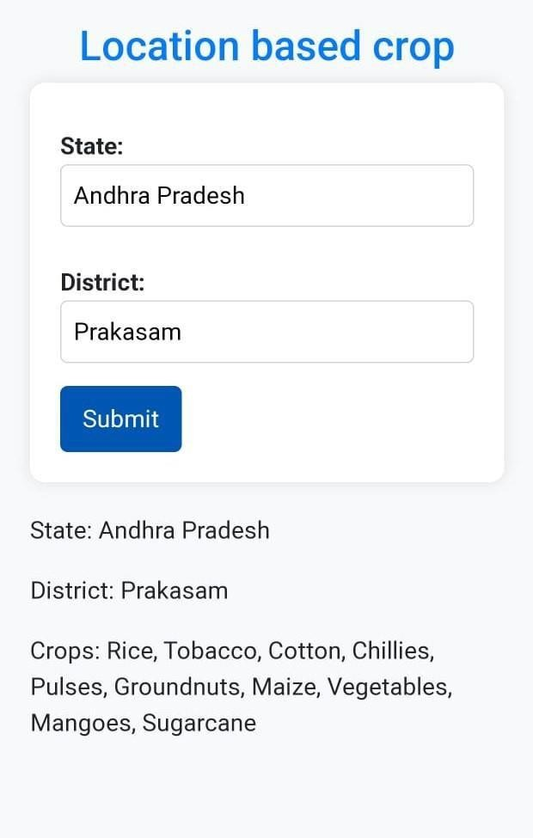

* 1. **CONCLUSION**

The comprehensive suite of features in our app empowers farmers with actionable insights and recommendations to optimize crop management practices. By providing accurate disease detection, personalized fertilizer recommendations, crop recommendations based on location and soil type, seasonal notifications, and a feedback system, the app enhances decision-making processes and improves agricultural productivity and sustainability. Ongoing discussions and feedback from users will further refine and enhance the app's functionality, ensuring its continued effectiveness in supporting the needs of the agricultural community.

**REFERENCES**

1. Rakesh Kumar, M.P. Singh, Prabhat Kumar and J.P. Singh, “Crop Selection Method to Maximize Crop Yield Rate using Machine Learning Technique”, International Conference on Smart Technologies and Management for Computing,

Communication, Controls, Energy and Materials, 2015

1. Haedong Lee and Aekyung Moon, “Development of Yield Prediction System Based on Real-time Agricultural Meteorological Information”, 16th International Conference on Advanced Communication Technology, 2014

##### International Journal of Innovative Research in Computer and Communication Engineering

**| e-ISSN: 2320-9801, p-ISSN: 2320-9798|** [**www.ijircce.com**](http://www.ijircce.com/) **| |Impact Factor: 8.379 | Monthly Peer Reviewed & Referred Journal |**

**|| Volume 12, Issue 3, March 2024 ||**

**| DOI: 10.15680/IJIRCCE.2024.1203037 |**

1. T.R. Lekhaa, “Efficient Crop Yield and Pesticide Prediction for Improving Agricultural Economy using Data Mining Techniques”, International Journal of Modern Trends in Engineering and Science (IJMTES), 2016, Volume 03, Issue 10
2. Jay Gholap, Anurag Ingole, Jayesh Gohil, Shailesh Gargade and Vahida Attar, “Soil Data Analysis Using Classification Techniques and Soil Attribute Prediction”, International Journal of Computer Science Issues, Volume 9,

Issue 3

1. S. D. Khirade and A. B. Patil,” Plant Disease Detection Using ImageProcessing,” 2015 International Conference on Computing CommunicationControl and Automation, 2015, pp. 768-771, DOI: 10.1109/ICCUBEA.2015.153
2. Israni, Dishant and Masalia, Kevin and Khasgiwal, Tanvi and Tolani, Monica and Edinburgh, Mani, Crop-Yield Prediction and Crop Recommendation System
3. Crop recommendation system by Shafiulla Shariff, Shwetha R B, Ramya O G, Pushpa H, Pooja.
4. Crop Recommendation System for Precision Agriculture S.Pudumalar*, E.Ramanujam*, R.Harine Rajashree, C.Kavya, T.Kiruthika, J.Nisha.
5. Anshal Savla, Parul Dhawan, Himtanaya Bhadada, Nivedita Is- rani, Alisha Mandholia, Sanya Bhardwaj (2015), ‘Survey of classification algorithms for formulating yield prediction accuracy in precision agriculture’, Innovations in Information, Embedded and Communication systems (ICIIECS).
6. Nischitha K, Dhanush Vishwakarma, Mahendra N, Ashwini, Manjuraju M R, “Crop Prediction using Machine Learning Approaches”, International Journal of Engineering Research and Technology, vol.9 Issue 08, August-2020 ISSN: 2278-0181.
7. Jayaprakash, S., Nagarajan, M.D., Prado, R.P.D., Subramanian, S. and Divakarachari, P.B., 2021. A systematic review of energy management strategies for resource allocation in the cloud: Clustering, optimization and machine learning. Energies, 14(17), p.5322.
8. Zeel Doshi, Subhash Nadkarni, Rashi Agarwal and Neepa Shah, “AgroConsultant: Intelligent Crop Recommendation System using Machine Learning Algorithms”,2018 Fourth International Conference on Computing Communication Control and Automation.
9. Priyadharshini A, Swapneel Chakraborty, Aayush Kumar, Omen Rajendra Pooniwala, “Intelligent Crop Recommendation System using Machine Learning”, Proceedings of the Fifth International Conference on Computing Methodologies and Communication (ICCMC 2021).
10. Shilpa Mangesh Pande, Prem Kumar Ramesh, Anmol, B R Aishwarya, Karuna Rohilla and Kumar Shaurya, “Crop Recommendation using Machine Learning Approach”, Proceedings of the Fifth International Conference on Computing Methodologies and Communication (ICCMC 2021).
11. Bondre, Devdatta A., and Santosh Mahagaonkar. "Prediction of Crop Yield and Fertilizer Recommendation Using Machine Learning Algorithms." International Journal of Engineering Applied Sciences and Technology 4, no. 5 (2019): 371-376.
12. Reddy, D. Anantha, Bhagyashri Dadore, and Aarti Watekar. "Crop recommendation system to maximize crop yield in ramtek region using machine learning." International Journal of Scientific Research in Science and Technology 6, no. 1 (2019): 485-489.
13. Azizkhan F Pathan, Chetana Prakash, Attention-based position-aware framework for aspect-based opinion mining using bidirectional long short-term memory, Journal of King Saud University - Computer and Information Sciences, 2021, ISSN1319-1578.
14. Azizkhan F Pathan, Chetana Prakash, Unsupervised Aspect Extraction Algorithm for opinion mining using topic modeling, Global Transitions Proceedings, Volume 2, Issue 2, 2021, pp. 492-499, ISSN 2666-285X
15. Dighe, Deepti, Harshada Joshi, Aishwarya Katkar, Sneha Patil, and Shrikant Kokate. "Survey of Crop Recommendation Systems." (2018).
16. Jaiswal, Sapna, Tejaswi Kharade, Nikita Kotambe, and Shilpa Shinde. "Collaborative Recommendation System For Agriculture Sector." In ITM Web of Conferences, vol. 32. EDP Sciences, 2020.
17. Parismita Bharali, Chandrika Bhuyan, Abhijit Boruah, “Plant Disease Detection by Leaf Image Classification

Using Convolutional Neural Network” ICICCT 2019, pp.194-205.

1. .Garanayak, Mamata, Goutam Sahu, Sachi Nandan Mohanty, and Alok Kumar Jagadev. "Agricultural Recommendation System for Crops Using Different Machine Learning Regression Methods." International Journal of Agricultural and Environmental Information Systems (IJAEIS) 12, no. 1 (2021): 1-20.
2. .Jejurkar Siddhi, S., S. Bhosale Meghna, and D. N. Wavhal. "Crop Predication and Diseases Detection Using Machine Learning." (2021).
3. .Rajak, Rohit Kumar, Ankit Pawar, Mitalee Pendke, Pooja Shinde, Suresh Rathod, and Avinash Devare. "Crop recommendation system to maximize crop yield using machine learning technique." International Research Journal of Engineering and Technology 4, no. 12 (2017): 950-953

##### International Journal of Innovative Research in Computer and Communication Engineering

**| e-ISSN: 2320-9801, p-ISSN: 2320-9798|** [**www.ijircce.com**](http://www.ijircce.com/) **| |Impact Factor: 8.379 | Monthly Peer Reviewed & Referred Journal |**

**|| Volume 12, Issue 3, March 2024 ||**

**| DOI: 10.15680/IJIRCCE.2024.1203037 |**

1. .Mahule, Ankit Arun, and A. J. Agrawal. "Hybrid Method for Improving Accuracy of Crop-Type Detection using Machine Learning." International Journal 9, no. 2 (2020).
2. .Akshatha, K. R., and K. S. Shreedhara. "Implementation of machine learning algorithms for crop recommendation using precision agriculture." International Journal of Research in Engineering, Science and Management (IJRESM) 1, no. 6 (2018): 58-60.
3. .Dighe, Deepti, Harshada Joshi, Aishwarya Katkar, Sneha Patil, and Shrikant Kokate. "Survey of Crop Recommendation Systems." (2018).
4. .Jaiswal, Sapna, Tejaswi Kharade, Nikita Kotambe, and Shilpa Shinde. "Collaborative Recommendation System For Agriculture Sector." In ITM Web of Conferences, vol. 32. EDP Sciences, 2020.
5. .Ghadge, Rushika, Juilee Kulkarni, Pooja More, Sachee Nene, and R. L. Priya. "Prediction of crop yield using machine learning." Int. Res. J. Eng. Technol.(IRJET) 5 (2018).
6. .Kulkarni, Nidhi H., G. N. Srinivasan, B. M. Sagar, and N. K. Cauvery. "Improving Crop Productivity Through A Crop Recommendation System Using Ensembling Technique." In 2018 3rd International Conference on Computational Systems and Information Technology for Sustainable Solutions (CSITSS), pp. 114-119. IEEE, 2018